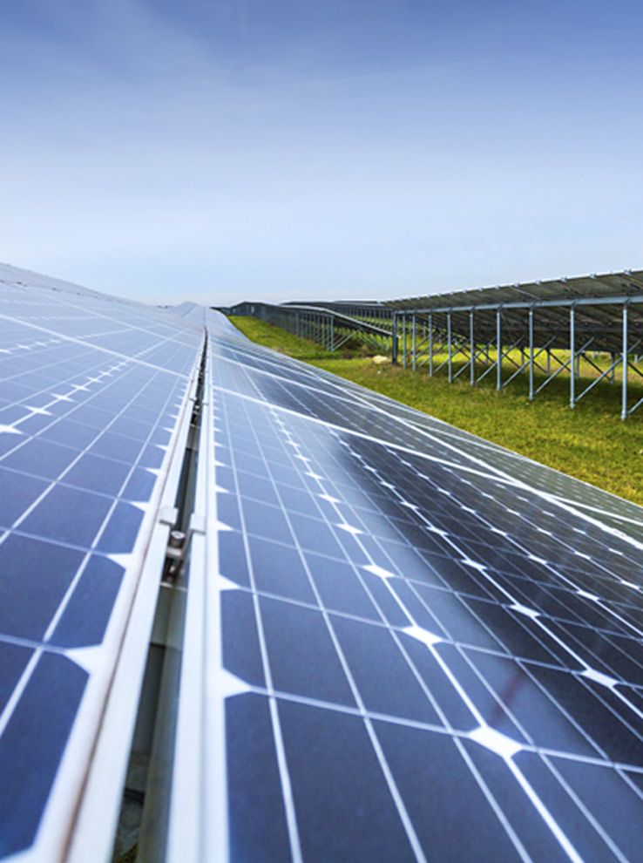



Information Brief

**Afghanistan Scaling Solar – Herat (40 MW PV Solar)**

TABLE OF CONTENTS

1. Disclaimer 3

2. Background 4

3. Project OVERVIEW 5

4. Expected Commercial Structure 7

5. Project Strengths 8

6. Project Timeline and Next Steps 9

7. Contact Details 9

8. Annex – Country Overview & Energy Sector 10

# Disclaimer

This Teaser (the “Teaser”) was compiled by International Finance Corporation (“IFC”) in relation to the structuring and tendering of a 40 MW solar power plant in Afghanistan (“Project”) under Public Private Partnership (“PPP”) mode.

The purpose of this Teaser is to acquaint prospective bidders/investors to the Project. No representation, warranty, or undertaking (express or implied) is made and no responsibility is accepted by IFC as to the adequacy, accuracy, completeness or reasonableness of this Teaser or any further information, notice or other document at any time supplied in connection with the Project contemplated hereunder. The information contained in this Teaser is not to be assumed to be correct subsequent to its date of issue, and the issuance of this Teaser does not constitute a representation or warranty by the World Bank or IFC that this information shall be updated at any time after the date of issuance. Nothing herein or attached hereto is, or may be relied upon as, a promise or representation as to the future performance or policies of the Project.

This Teaser is not intended to provide the basis for a decision to bid/invest/participate in the Project. Any decision to participate in the Project should not be considered as a recommendation by IFC that any recipient of it should participate in the Project /transaction hereunder.

Each recipient of this Teaser should make (and will be deemed to have made) its own determination of the relevance of the information contained herein and its own independent investigation and assessment of the Project, and the terms and conditions of the proposed financing. The illustration of any results and cash flows (if any) contained herein as well as any other estimates or projections should on no account be taken as forecasts or otherwise relied upon and should be read in conjunction with the assumptions and notes set out hereto, and no assurance can be given that they will be achieved or proved correct. This Teaser, the illustration of results and cash flows (if any) contained herein as well as any other estimates or projections should not be viewed as a substitute for such independent evaluation and investigation by a prospective bidder/investor. No representation or warranty is made by IFC as to the correctness, accuracy, adequacy, completeness or reasonableness of the projections and assumptions (if any) used.

Prospective bidders/investors should be aware that: (a) to the extent any of the information contained herein or on which the financial model (if applicable) was based constitutes an assumption, forecast, projection or other data, which by its nature is uncertain, including but not limited to, revenue projections, future operating costs, future cost of capital (including inflation and currency exchange risks) and related economic and financial factors, there can be no assurance that future actual results and economic and financial conditions will not differ significantly from such assumptions, forecasts, and projections; and (b) as to the information supplied by third parties, IFC represents only that it is not aware of any material misstatement or omission therein.

This Teaser is proprietary and for the confidential use of only those persons to whom it is distributed by IFC in connection with the tendering of the Project. Its use for any other purpose is not authorized, and it may not be reproduced or redistributed in whole or part, or divulged to, or shared with others, or used for any purpose other than the analysis of the project, without specific IFC authorization in writing. No other person has been authorized to give any information or make any representations with respect to the Project other than the information contained in this Teaser, and, if given or made, such other information or representations must not be relied upon as having been authorized.

# Background

At present, approximately 70% of Afghanistan’s total power capacity of 1,450 MW is imported from the neighboring countries of Tajikistan, Turkmenistan, Uzbekistan and Iran. Access to electricity remains low, around 34 percent, and it is focused in urban areas and along transmission corridors that are connected to imported energy. Afghanistan’s per capita electricity consumption averages 178 kilo Watt-hour (kWh) per person per year, significantly less than the South Asian average of 667 kWh per person and the average electricity usage of 3,050 kWh per person worldwide (based on 2015 data). Nevertheless, electricity access has expanded steadily, and the number of customers has grown from only a few tens of thousands in 2004 to over 1.5 million as of August 2018.

The 2013 Power Sector Master Plan prepared by the Ministry of Energy and Water (MoEW) presented a 20-year electricity demand forecast requiring a base case peak load of 3,500 MW and assessing a gross demand of 18,500 GWh by 2032. To meet this demand, the Power Sector Master Plan identified a combination of increasing domestic energy generation as well as imports. One of Government of Islamic Republic of Afghanistan (GoIRA)’s recent initiative to bridge the electricity access and shortfall is advancing a 2,000 MW renewable energy program as part of a wider green growth agenda.

The GoIRA acting through the MoEW (the Procuring Authority) has engaged the International Finance Corporation (IFC), a member of the World Bank Group, acting through its Public Private Partnership (PPP) Transaction Advisory Services division, to act as lead transaction advisor to invite private sector developers to compete for the right to develop, finance, construct, operate, maintain and transfer an independent utility-scale solar photovoltaic (PV) power project in Afghanistan of up to 40MW (Project) under the World Bank Group’s ‘Scaling Solar’ initiative.

Scaling Solar is an open, competitive and transparent approach that facilitates the rapid development of privately-owned, utility-scale solar PV projects, offering a ‘one-stop-shop’ package of contracts, financing, guarantees and insurance.

IFC, in assistance with international/domestic consultants, has undertaken technical, commercial and legal due diligence. After GoIRA approval of transaction structure, IFC will initiate transparent bidding process leading to the procurement of a private developer.

# Project OVERVIEW

|  |  |
| --- | --- |
|  |  |
| Project | * Up to 40MW green-field solar PV based power project. |
| Location | * 81.6 hectares, south of Guzara District, Herat. |
| Project Structure | * The private developer will develop the Project under a Design-Build-Finance-Operate-Maintenance-Transfer (DBFOMT) contract or similar arrangement. * Power Purchase Agreement (PPA) and Government Support Agreement (GSA) is expected to be maximum 25 years. Under the Scaling Solar program, the PPA and GSA (Project Documents) have been designed to provide a fair and reasonable balance between the interests of the relevant host government and utility (on the one side) and the relevant developer and its lenders (on the other). * Take and Pay offtake arrangement under PPA. DABS will purchase and accept all energy generated by the power plant. |
| Credit Enhancement | * Under the Scaling Solar package, political risk insurance from Multilateral Investment Guarantee Agency (MIGA)[1] and partial risk guarantees from International Development Association (IDA)[2] are likely to be available and can be opted to credit enhance the transaction structure. |
| Progress to-date | * GoIRA/MoEW identified the site and in assistance with an IFC and other consultants is finalizing the transaction structure based on due diligence undertaken by consultants:   + - * Technical and environmental consultant: * GOPA-International Energy Consultants, Germany/ Dynamic Vision, Afghanistan   + - * Legal advisors” * Linklaters, LLC, UAE/ Kakar Advocates, Afghanistan |

***Location & Site***

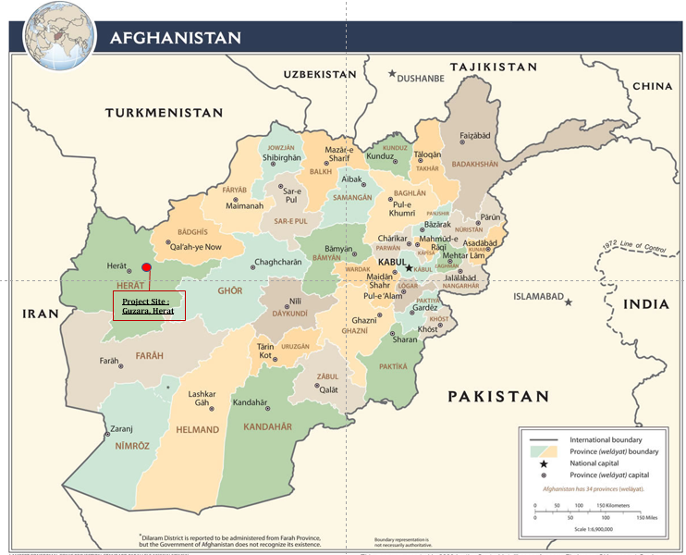

***Status of project preparations***

* + - * Preliminary studies have been undertaken to evaluate solar resource, geotechnical, topographic, hydrological, seismic site conditions. The site is approximately 22 km from Herat city centre and about 6 km from Guzara City centre and located to the west of the Kandahar - Herat Highway, approximately 1.2 km long and 0.67 km wide with an area of 0.81 km². suitable for development of a solar PV power plant. Studies will be provided to shortlisted bidders on reliance basis.
      * Grid integration studies and a grid impact assessment, load flow and contingency analyses have been completed to understand voltage profiles, equipment loading, power exchange and system losses during different operating conditions of the proposed Herat PV plant, to establish power evacuation and other technical parameters. The Project will be connected to the existing Herat 132/20 kV substation (Shohada-e-24Hoot) - serving the existing Herat sub-grid load. The approximate distance between the PV site and the Shohada-e-24Hoot substation is around 5.7 km. Peak load in 2021 is projected to 155 MW / 49 MVar, and generation capacity will partly offset higher-cost power imports from Iran to the system. Studies indicate the Herat transmission system can support evacuation of the power from the PV power plant without overloading any of the existing transmission lines or transformers.
      * An indicative layout and project design has been prepared by consultants to validate the feasibility and commercial viability of the project.
      * A legal due diligence has been undertaken to confirm the legal feasibility of the IPP and consistency of the Scaling Solar PPA/ GSA templates with the Afghanistan legal framework. The legal due diligence will be provided to shortlisted bidders on reliance basis.

# Expected Commercial Structure

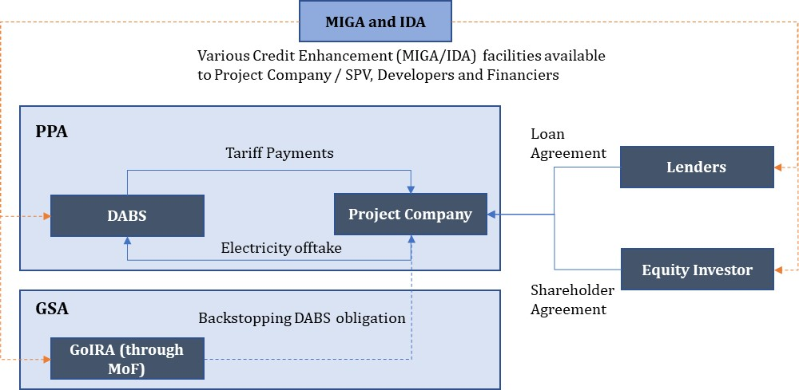

The World Bank Group Scaling Solar initiative has been designed to enable governments and utilities to execute quick, simple, professional, transparent and competitive tenders to procure high quality, privately designed, built, owned and operated solar PV power plants under long-term contracts at competitive tariffs.

*Market-tested, “bankable” contract documentation:* Under the Scaling Solar program, a 20 – 25 year offtake / PPA agreement will be entered into by Da Afghanistan Breshna Sherkat (DABS), the government owned national utility. DABS will purchase and accept all energy (up to the contracted capacity) generated by the power plant. The tariff for energy generated during the operating period will be specified by bidders as part of the tendering proposal.

*Comprehensive credit enhancement framework:* The contract framework provides for a Government Support Agreement (GSA) with the GoIRA, acting through the Ministry of Finance, under which the GoIRA will undertake to provide certain protections and other support to the Project, including support to developer in discharging DABS’ obligations which could adversely affect the Project.

*Stapled financing:* Under the Scaling Solar program, MIGA would expect to be able to provide political risk insurance in support of the financing, and IDA would likely be able to consider the provision of an IDA guarantee (for financiers against a breach of certain payment obligations by the DABS), subject to a GoIRA request and uptake by the winning bidder).

The terms of the IFC financing, MIGA insurance and IDA guarantee, and whether these would be made available, would be subject to the terms of detailed agreements and due diligence on the specific project’s commercial and other fundamentals, and on the winning bidder and on the other stakeholders to be involved in the Project.

# Project Strengths

|  |  |
| --- | --- |
|  |  |
| Bankable Project Documents | Scaling Solar program Project Documents have been successfully executed in various countries to achieve commercial close of first-of-a-kind utility scale PV solar projects. The documentation is designed to provide a fair and reasonable balance between the interests of the stakeholders. |
| Stapled financing facilities and risk mitigation | The Scaling Solar program enjoys the support of the World Bank Group. IFC working in partnership with its World Bank Group sister organizations, the IDA and the MIGA is likely to be able to provide IFC investment and credit enhancement / risk mitigation instruments. |
| Strong demand and offtake commitment, limiting any curtailment risk | Afghanistan remains in the bottom 10% globally in electricity consumption per capita and one third of its population is connected to the grid - one of the lowest rates in the world. Government (through DABS) will offtake all generated electricity (capped to contracted capacity) to partially meet the electricity requirements. |
| High level of Government commitment | There is strong level of government commitment to make the project successful as a precedent for a scale up of domestic renewables and to develop a template for future renewables IPPs in the country. |
| Site security | Herat province is a relatively safe part of Afghanistan with limited instances of violence. The overall security situation of Guzara district benefits from its proximity with a Afghan National Army unit, and security risks will be borne by GoIRA under the terms of PPA and GSA. |
| Tariff | Tariffs will to be paid equivalent to amounts payable in US Dollars; government will bear convertibility, transfer and exchange rate risks |

# Project Timeline and Next Steps

IFC, in assistance with international/domestic consultants, has undertaken technical, commercial and legal due diligence. After GoIRA approval of transaction structure, IFC will initiate transparent bidding process leading to the procurement of a private developer. Expected timeline for Request for Proposal (RfP) is summarized as follows:

|  |  |
| --- | --- |
|  |  |
| Request for Qualification issuance date | October 2019 |
| Clarification request deadline | November 2019 |
| Prequalification Application Submission Deadline | November 2019 |
| Announcement of Prequalified Bidders | December 2019 |
| Government approval* and RFP issuance / Data Room launched | December 2019 |
| *\*subject to MEW/ MoF approval of transaction structure* |  |

As part of the market sounding for the proposed project, feedback on your indicative interest in the project and preliminary views on the following aspects would be appreciated:

* Project scope
* Risk allocation
* Credit enhancement
* Financing strategy

# CONTACT DETAILS

For further inquiries and follow up, please direct your queries to afghanscalingsolar@ifc.org

# Annex – Country Overview & Energy Sector

Since 2001, Afghanistan has achieved substantial improvements, particularly in expanding access to water, sanitation and electricity, education and health services. Macroeconomic management remains strong, government revenues have grown rapidly since 2014, and the government has engaged in a range of business environment and public financial management reforms.

Afghanistan faced severe economic headwinds in 2018, with the economy growing by an estimated 1.8 percent. Two main factors drove the slow growth. Firstly, severe drought had a strong negative impact on agricultural production. Secondly, uncertainty around the level and duration of international security assistance and prospects of a peace settlement. Various efforts towards a political stability have been ongoing. Growth is expected to accelerate by 2021 assuming a smooth political transition after the September 2019 elections. Long term growth prospects are predicated on improvements in security, steady progress with reforms, and sustained aid.

Afghanistan’s electricity mix is dominated by electricity imports that are complemented by domestic hydropower. The country has limited indigenous sources of electricity, with only approximately 500 MW of installed capacity. The installed capacity is a mix of hydro (in majority), thermal, and diesel. This compares to more than 1,100MW of imported electricity from four neighboring countries: the Islamic Republic of Iran, Tajikistan, Turkmenistan, and Uzbekistan. Imports are based on annual PPAs with these countries.

Nearly 1.2 million customers are connected to the grid, comprising nearly 30% of the country’s population. Afghanistan has 10 sub-grids with limited interconnectivity, supplied by different power systems through 220-kV and 110-kV links. Peak demand in 2018 is about 2,000 MW. With the help of donors and private sector, the government intends to enhance the power generation and transmission network. On the distribution front, the government, with assistance from development partners, is funding major distribution expansion programs across major load centers of the country. Due to frequent energy shortages, many Afghans have to rely on electricity produced by costly, privately-owned diesel generators that can be used only a few hours a day.

1. MIGA, a member of World Bank Group - international financial institution which offers political risk insurance and credit enhancement guarantees
2. IDA, a member of World Bank Group - international financial institution which offers concessional loans and grants to the world's poorest developing countries