



# ISLAMIC REPUBLIC OF AFGHANISTAN

**Ministry of Public Health**

**Project Information Memorandum**

**Development of Diagnostic Centre at Ibni Sina Hospital   
Compound (Kabul) by PPP using BOT model**



**January 2020**

**Contents**

**Disclaimer 3**

**Introduction 4**

**Purpose of PIM 6**

**Country Overview 9**

**Healthcare Sector Overview 10**

**PPP Framework 12**

**Project Description 15**

**Commercial 17**

**Legal 21**

**The Road Ahead 24**

**Appendix 26**

**Contact Information 32**

**DISCLAIMER**

This Project Information Memorandum (PIM) has been prepared by Advisors to Central Partnership Authority (CPA) on behalf of and in consultation with the Ministry of Public Health (MoPH), Afghanistan.

This PIM does not purport to be all inclusive or to contain all the information that a prospective bidder or participant in the project may require in making its decision to participate in the tender. Where this document describes any contractual, commercial or other legal arrangements which are not yet in force, those arrangements remain subject to change.

MoPH reserves the right to change the procurement of the project or any other plans or information relating to the project. In particular MoPH reserves the right at any time, to issue amendments or modifications to this PIM; to alter the timetable for the project; and/or not to proceed with the project. MoPH will not be responsible for the costs or expenses of any recipient of the PIM in relation to any matter referred to in this document, including costs relating to the consultation or in respect of the evaluation of, award, or any bid for the award, of a Project Agreement and/or any other contractual arrangements relating to the project.

Neither MoPH, CPA nor their Advisors make any representation, undertaking or warranty (express or implied) as to the accuracy, reasonableness or completeness of this PIM and no such body or person has any authority to make any such representation or warranty, whether on its own account or on behalf of any other. All such bodies and persons expressly disclaim any and all liability for, or based on or relating to any of the information in this PIM or any errors or omissions in the same, or for any use made by the recipients of the PIM.

Recipients of this PIM should not, therefore, rely on the information provided in this PIM and should form their own views as to what information is relevant and undertake their own due diligence, investigations, projections and consult their own advisers to verify independently the information and to obtain any additional information that it may require, prior to submitting a proposal for the project.

Neither the receipt of this document by any person nor any information contained in it or distributed with it or subsequently communicated to any interested party or its advisers is or is to be taken as constituting the giving of advice by MoPH or CPA.

# 

**INTRODUCTION**

The Ministry of Public Health (MoPH) of Afghanistan is seeking to improve the health status of the population of Kabul as well as Afghanistan by the establishment of a small-scale Diagnostic Center in Ibn-e-Sina Hospital at Kabul under Public Private Partnership (PPP). The goal of this project is to establish a cost-effective, affordable, and efficient center for diagnostic facilities based on assessment of the local communities’ needs and available resources. Accordingly, High Economic Council (HEC) of government approved for establishing Diagnostic Facilities under PPP in Kabul as a pilot basis.

In achieving the objectives of the project, MoPH will be seeking bids from the private sector to design, built, finance, operate and transfer a diagnostic center within land provided at Ibni Sina Hospital to provide diagnostic imaging and laboratory services.

As part of the feasibility stage of the project, a number of assessments have been undertaken to establish demand and willingness to pay for the services so as to structure a bankable transaction that will provide investment returns to the private sector and meet the objectives of the MoPH. These include:

* Assessment of the current operations of the selected hospitals/diagnostic centers of the state and identify their needs. Also included assessing the availability of diagnostic services for the district population with the public and private facilities, assessing the business environment in terms of market dynamics, pricing competition, regulations and detailed sensitivity analysis on the base case projections with respect to the key drivers affecting revenue, streams of business and capital cost.
* Survey of similar successful PPP models and operating models across neighboring countries.
* Assessment of the nine public hospitals plus one military hospital in Kabul city to assess the readiness of the hospitals for the PPPs and gather information on the current status of provision of the imaging/diagnostic services. This included, demand for the services, physical status of the hospitals, and the willingness of the hospitals’ management to engage with the PPP process. A number of criteria were considered for that analysis including, space availability, provision of diagnostic imaging services, diagnostic imaging staff, current fees, accessibility, supply of electricity, etc.
* Assessment of laboratory services in the vicinity of Ibni Sina Hospital including assessing the demand, quality of services and willingness to pay so as to establish the desirability of including laboratory services in the scope of works.

Hence, the proposed services include several imaging services such as, MRI, CT-Scan, X-ray, Ultrasonogram, Angiogram, ECG, Endoscopy, ETT and Echocardiogram and laboratory services including Blood and Urine Tests, Cardiac Stress Tests and Pulmonary Function Tests.

To achieve MoPH’s objectives, bidders will be expected to demonstrate

* Capability to deliver the projects;
* Deliverability of their bid with a particular focus on the technical and financial aspects;
* Commitment of skills transfer from international to national personnel;
* Innovation and efficiency - the project is focused on achieving MoPH’s output specification so bidders will have the latitude to innovate within affordability and deliverability limits; and
* Operational performance to ensure user fees are affordable.

The Request for Proposals (“RFP”) that will be issued to prequalified bidders will describe in detail our requirements and support being provided towards the Project. MoPH will seek in the RFP to provide flexibility for bidders to determine how to achieve these aims.

MoPH is interested in receiving proposals that provide for an extremely quick delivery timetable for this project. In particular, MoPH would welcome proposals on how alternative funding structures might be developed to lower the cost of capital.

**PURPOSE OF PIM**

This PIM forms part of MoPH and CPA’s approach to promoting transparency and initiating meaningful dialogue with the private sector.

In developing this PIM, MoPH and CPA have engaged with the market extensively. First, market consultation events have been conducted to introduce this project and other MoPH PPP projects to the market. In addition, during the Prequalification process, a number of Pre-Application meetings were held which provided an avenue for interested companies/ consortia to provide their views on the pre-qualification criteria, scope of works and key bankability provisions to enable the successful implementation of this project. Following market feedback, MoPH and CPA have reviewed the scope of work and included advance laboratory services into the project.

The aim of the PIM is to set out our current intent with regard to this project, provide relevant information to the market and seek additional views particularly from prospective investors and operators. Information is also being provided to a greater detail to enable potential bidders prepare their consortia and commence internal approvals ahead of the reissue of the Request for Prequalification (“RFQ”).

Upon the reissue of the RFQ, discussions will only be permitted in accordance with the prescribed rules of the tender. Prospective bidders are therefore encouraged to provide feedback/views and suggestions to MoPH and CPA prior to the resumption of the competitive process.

We are transparent about the fact that our thinking and final position on a number of areas within the scope of this procurement and concession specification are still being developed and, in many cases, are subject to final GoIRA approval. As such, the information in this document should not be relied upon as an indication of our final requirements for the eventual PPP structure and agreement; indeed, we will continue to welcome feedback on our proposed approach where this is still under review.

In achieving the aim of this PIM, MoPH and CPA would welcome comments on a number of issues set out in this PIM. In particular, views on the following are encouraged:

1. Scope of work
2. The proposed project and transaction structure
3. Risks and concerns associated with the project
4. The proposed procurement process and timetable

**Market Sounding Process**

MoPH and CPA is soliciting response to its Questionnaire attached as Appendix to this document. These questions will be discussed in 1 on 1 meetings with potential bidders, consortia, investors, operators, financiers and industry players between 27th and 29th January 2020. Following this meeting, written responses may be submitted to the following email addresses:

[ppphealth.moph@gmail.com](mailto:ppphealth.moph@gmail.com) and copy [matin.zahid@gmail.com](mailto:matin.zahid@gmail.com), [talha.hidayat@mof.gov.af](mailto:talha.hidayat@mof.gov.af) and [ozair.stanekzai@mof.gov.af](mailto:ozair.stanekzai@mof.gov.af)

The 1 on 1 dialogue is intended to allow for further clarification and the raising of any perceived commercially sensitive queries regarding the project and for MoPH and CPA to obtain feedback on its approach. Allocation of slots for the meetings will be on a first come first serve basis and as such, interested participants are strongly encouraged to submit their requests as soon as possible. Applications for a 1 on 1 meeting should be submitted by email as follows:

1. To the following addresses:

[ppphealth.moph@gmail.com](mailto:ppphealth.moph@gmail.com) and copy [matin.zahid@gmail.com](mailto:matin.zahid@gmail.com), [talha.hidayat@mof.gov.af](mailto:talha.hidayat@mof.gov.af) and [ozair.stanekzai@mof.gov.af](mailto:ozair.stanekzai@mof.gov.af).

Note: Kindly send to all given email addresses.

1. With the subject: ***Diagnostic Center PPP: Application to attend a 1 on 1 meeting***
2. Include details such as: ***company name, address, country(ies) active, nature of business (Investor/ Equity provider, Developer, Contractor, Equipment Supplier, Operator, or Lender)***
3. *Propose:* ***preferred date and time***

**Conditions of Participation**

By accepting an invitation to participate in the market sounding process being undertaken by MoPH and CPA, participants note and agree to the following conditions:

* The market consultation meeting is being undertaken on a ‘no commitment’ basis and does not form part of the formal procurement process for engaging private sector implementation assistance. Participation in the market sounding process does not act to pre-qualify participants for any future tender process.
* Participation is voluntary and MoPH will not be responsible for any costs incurred by organizations associated with either preparation or participation in the market sounding process.
* Only employees and authorized of invited private sector organizations are to attend the market consultation meetings.
* MoPH will keep a record of the discussions at the market consultation meetings. However, these records will be of a generic nature and will not identify any individual participant or contributor.
* MoPH reserves the right to use information gained from the meetings or questionnaire responses on a non-attributable basis during the assessment of the project, including evaluation of the private sector participation options and subsequent procurement of the project.

**COUNTRY OVERVIEW**

# Afghanistan is a landlocked mountainous country located within South Asia and Central Asia. The country is the 40th largest in the world in size. Kabul is the capital and largest city of Afghanistan, located in the Kabul Province. The Hindu Kush mountains, running northeast to southwest across the country, divide it into three major regions: 1) the Central Highlands, which form part of the Himalayas and account for roughly two thirds of the country's area; 2) the Southwestern Plateau, which accounts for one-fourth of the land; and 3) the smaller Northern Plains area, which contains the country's most fertile soil.

# Image result for afghanistan map

# Kabul is located high up in a narrow valley between the Hindu Kush mountains, with an elevation of 1,790 meters (5,873 ft) making it one of the highest capitals in the world. The city is said to be over 3,500 years old, mentioned since at least the time of the Achaemenid Empire. It is at a strategic location along the trade routes of South and Central Asia, and a key location of the ancient Silk Road.

**HEALTHCARE SECTOR OVERVIEW**

The health system in Afghanistan has improved drastically since 2002 (1381) with the creation and implementation of the basic package of health services (BPHS) and later the essential package of hospital services (EPHS). Introduction of the BPHS and the EPHS led to a greater cohesion of services offered in the public health system, which is under the stewardship of the Ministry of Public Health (MoPH). However, many health indicators for Afghanistan remain poor. For example, life expectancy remains less than 65 years, a recent measure of infant mortality showed it to be at 77/1,000 live births, and maternal mortality at 327/100,000 live births.

Radiological diagnostic service is required for providing effective diagnosis of the disease suffered by the patient, measuring the quantum of medicines to be provided, quantifying the extent of cure effected, and identifying the medical sensitivities of the patient to avoid wrong/under/over medication resulting in adverse effects and to extend the research and development capabilities of the medical process.

Likewise, laboratory is an important component in healthcare and is widely acknowledged as the seat of medicine. Most critical treatment decisions are based on laboratory results and with the advent of information technology and computers; people are becoming more and more health conscious. Lifestyle related diseases, which require diagnostic and therapy interventions are also on the rise. This, against the backdrop of most prevalent diseases like coronary heart diseases, lungs diseases, stroke, tuberculosis, liver diseases and cancer present a grim picture.

Rates for many of the top ten causes of death (for example, ischemic heart disease at 8.1% of total deaths, stroke at 6.4%, pre-term birth complications at 5.2%, and road injuries at 2.6%) would likely be lower if better diagnostic services were more readily available within the public sector. Currently, these services are very limited within the public sector and when equipment is available, it is often out of service because of either a lack of funding for repairs or an absence of technical know-how in Afghanistan to service the equipment.

These loopholes in the system adversely affect the efficiency and operation of healthcare centres by the following means:

1. Delaying the treatment procedure
2. Restricting the treatment capacity of the medical practitioners
3. Absence of proper diagnostics may lead to judgmental errors on the condition of the patients
4. Everyone is immune or counter reactive to certain drugs and chemicals, lack of diagnostic service may adversely affect the treatment outcomes.

**Major Gaps in diagnostic services in Afghanistan** 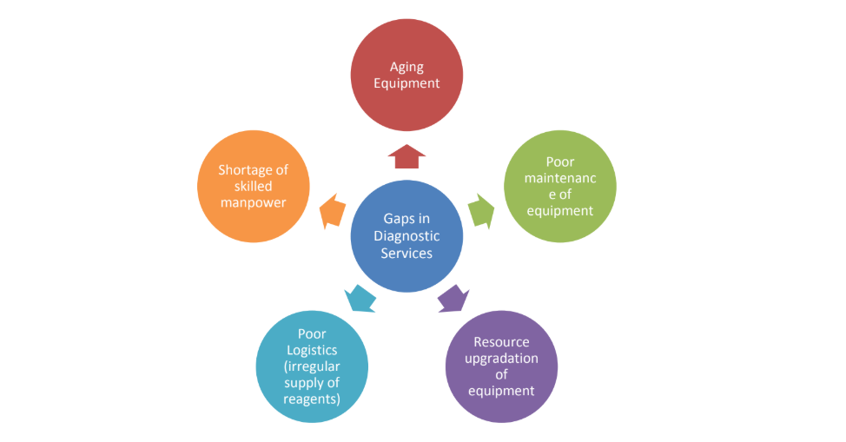

The country’s vast healthcare infrastructure is broadly divided into the public and private (including non-governmental donor hospitals) sectors, depending upon their ownership. Kabul is the heart of Afghanistan’s healthcare services and has the largest number of private and government facilities. Kabul city has an estimated 20 speciality hospitals and more than 100 private hospitals as per the MoPH Licensing Department.

**PPP FRAMEWORK**

Afghanistan, like many developing countries, has been seeking ways to develop and improve infrastructure within the framework of limited fiscal capabilities. In recent years, the World Bank Group and other development partners have been working with the Government of Afghanistan on increasing private participation in infrastructure. Public-private partnerships are increasingly seen as a means to harness private innovation and finance while the government maintains ultimate ownership and insurance of the public interest.

The country now has an established PPP framework with the enactment of a PPP law, establishment of the central PPP body and approval of a PPP policy. Afghanistan also has a pipeline of PPP projects at various stages of the PPP lifecycle, has developed a PPP suitability and prioritization tool for project screening and selection, has prepared standard bidding documents and contracts, is currently preparing PPP regulations and building capacity across the public sector to enable the success of PPPs in the country.

*Despite the challenging environment in the country, Afghanistan has had some positive PPP experiences. The private sector has provided telecom services in Afghanistan for many years, through contracts awarded to Afghan Wireless, Roshan, MTN, Etisalat, and Wasel. These contracts were competitively tendered, monitored by the Afghanistan Telecom Regulatory Authority, produced over US$2 billion in private investment, and lowered tariffs by 95 percent since 2002. Thus, 75 percent of the public can subscribe to mobile services and mobile telephone subscriptions have increased to over 20 million, compared to less than 60,000 a few years ago. In addition, there is clear private sector appetite to engage in the energy sector, as demonstrated through the development of the Mazar-e-Sharif and Bayat Gas-to-Power Projects* ***(World Bank, 2018)***

## PPP Law

In 2016, the Afghanistan PPP Law was enacted and created the Central Partnership Authority, the law was later modified in 2018. The law provides the legal framework for PPPs in the country providing comfort to the private sector.

## PPP Policy

The Central Partnership Authority has developed the PPP policy under which the government motivates private sector to invest in public projects through long-term contracts where the liability, risk, profit and/or loss are shared by both ‘partners’ on equitable basis and depending on the ability to manage the risk of each one of them.

## Institutions

**Central Partnership Authority**

Under the PPP law, the Central Partnership Authority was established within the Ministry of Finance to regulate policies, undertake analysis, provide advice and technical support to contracting entities, streamline the process, promote PPPs and other relevant tasks. Regarding this PPP project, the specific functions of the CPA include:

1. Providing technical and administrative support and advice to MoPH, the Minister of Finance, the HEC, and the Cabinet on the implementation of this PPP project;
2. Monitoring and reporting on the performance and implementation of PPP agreements.

**Ministry of Finance**

In accordance to the PPP Law, the Ministry of Finance has the following powers and functions:

1. To approve, reject and return for revision the Concepts which are submitted for approval.
2. To approve, reject or return for revision the Prefeasibility Study, Feasibility Study of Partnership Project which is submitted for approval.
3. Submission of Partnership Contract after the notarization of High Economic Council to the Government (Cabinet).
4. To perform other powers and functions predicted in this law, the regulation or rules of procedure.

In particular, the MoF will be responsible for assessing and managing the financial commitments of the GoIRA to this project to ensure fiscal sustainability.

**High Economic Council**

The High Economic Council has the following key powers and functions under the PPP law:

1. To provide guidance, on regulating government’s over all policy and other framework of PPP sector in accordance to the GoIRA national strategic objectives.
2. To decide on financial and economic supports, guarantees, commitments of the State, and other aspects needed for implementation of the Project as per the provisions of this law.
3. To approve award of Partnership Contracts based on Public Private Partnership principals as per the provisions of this law.
4. To approve/reject/review amendment of Partnership Contracts as per the provisions of this Law, regulation and rules of procedure.

**Cabinet**

The Cabinet is responsible for the approval, amendment, rejection or review of the Partnership Contracts after approval by the by the HEC.

**The Concept Paper for this project has been approved by the HEC and Cabinet in accordance with the PPP law.**

# 

**PROJECT DESCRIPTION**

In order to strengthen select diagnostic imaging services, the Government of the Islamic Republic of Afghanistan through the Ministry of Public Health will enter into a Design-Build-Finance-Operate-Transfer Public- Private Partnership for the provision of services as listed below in Section “Equipment/Services to be Provided” at the proposed Diagnostic Centre at Ibni Sina Hospital Compound. This PPP Project will serve Kabul province and is intended to strengthen healthcare services to the residents of Kabul and other Afghanistan provinces.

## Asset Description

Ibni Sina complex is comprised of three independent functional health facilities possessing separate organizational structures. These three health facility centers include Ibne Sina Ajil, Ibne Sina Sadri, and Ibne Sina Radiology.

1. Ibni-Sina Ajil is a 200-bed component that consists of Internal Medicine, General Surgery, ENT, Dermatology, Vascular Surgery, and Emergency/ICU departments. The hospital was established in 1961 as an emergency hospital but has now been mandated to treat all patients that seek care.
2. Ibni-Sina Sadri component of the complex is a 60-bed health facility that consists of Thoracic Surgery, Pulmonology, and Cardiology departments. It was established in 1962 right next to Ibni-Sina Ajil
3. Ibni-Sina Radiology component of the complex consists of the department of radiology with currently operational x-ray and ultrasonography services.

## Location

The proposed land is inside the Ibni Sina Hospital area which is owned by the Ministry of Public Health. The site area is approximately 1,010 square feet surrounded by the boundary. In the frontage of the site, the ministry has allocated approximately 450 square feet to construct the hospital waiting area which will be shared with the diagnostic center.

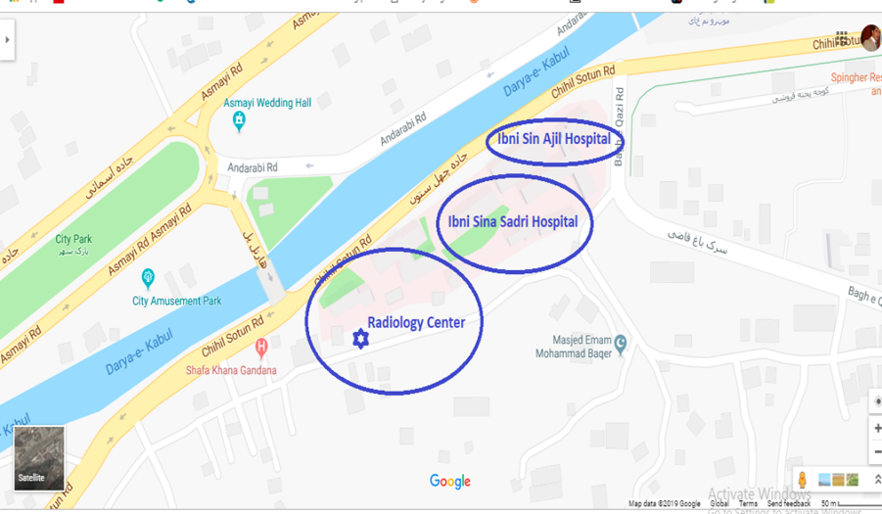

A separate space will be allocated other than the site area inside the waiting area for the private partner to set up its billing, administrative office and report delivery space. The private partner will be allowed to build a two or three story-building to cover the diagnostic equipment setup area. There is a 150KVA Generator operated by the hospital next to the site; which the private partner can be connected to for backup power. It will be required to pay a user fee to the backup power services provided.

## Equipment

All purchased equipment must be new at time of purchase. Bidders will be expected to specify for each piece of equipment how the equipment will be maintained (e.g. on-site service technician, manufacturer service agreements, off-site serving, etc.) during the life of the project. The basic equipment to be provided are:

|  |  |
| --- | --- |
| Machine | Quantity |
| MRI | 1 |
| CAT/CT Scan | 1 |
| Ultrasound | 1 |
| Echocardiogram | 1 |
| X-ray | 2 |
| Equipment to provide Standard Laboratory Services (Details TBA) | 1 set |

# 

**COMMERCIAL**

## PPP Model

The overall purpose of the PPP project is to design, construct the building, equip, operate and hand back to MoPH. The PPP project will include operation and maintenance services for the diagnostic services over a defined operating period. This PPP is also intended to ensure the highest-quality of standards for diagnostic imaging and laboratory services with the available resources, placing emphasis on overall performance and patient safety.

The term of the Project Agreement will expire after the defined period from the date of the award of the PPP Agreement. It is anticipated that the construction period for the Project will have duration of approximately 12 months.

## Project Structure

As currently envisioned, the transaction structure for the proposed Public-Private Partnership Project to provide select diagnostic imaging and laboratory services at Ibni Sina is as follows:

1. Contract Structure: Build-Operate-Transfer (BOT). The private party will build the diagnostic centre with its own funds and funds raised from lenders at its own risk. The private operator will also be responsible for operating the centre as well as maintaining the assets, which will be handed over back to government at the end of the concession period.

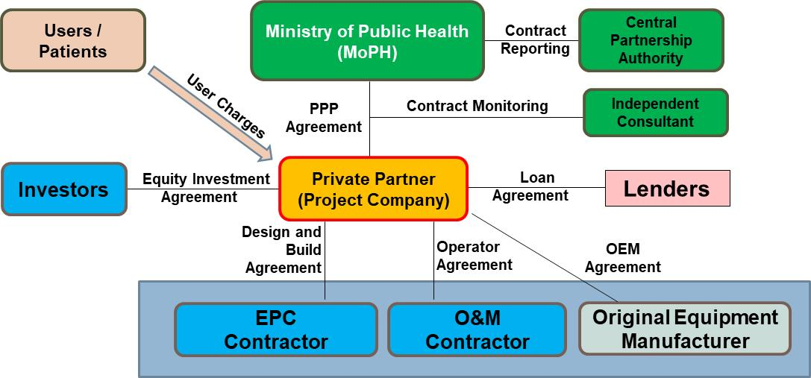

1. Contract Duration: Fifteen (15) to Twenty (20) years including the construction period. The duration will be finalized at the latter stages of the procurement process.
2. Required Minimum Investment Plan: At a minimum, the successful bidder will be expected to construct the Diagnostic Unit at Ibni Sina Hospital Compound such that the proposed equipment will remain operational during the life of the project, and that patient services can be offered at the optimal quality. It is expected that the proposed construction will meet current international standards for the proposed equipment list and services to be provided. The building for diagnostics services must be constructed based on the MoPH Planning and Design Standards or based on the parameters illustrated by the Afghanistan Building Codes (ABC) and the Afghanistan Architectural Code (AAC).
3. Revenue parameters and payment mechanism: All services delivered at the diagnostic center will be provided on a private patient commercial basis. The proposed structure is to have a BOT User Pay model where the patients pay directly to the private company for the services rendered. The prices will however be a bidding parameter with the aim of achieving the lowest aggregate cost of services. The price levels will therefore be agreed and set in the PPP Agreement.
4. Roles and Responsibilities:
   1. Ministry of Public Health (Entity / Implementation Agency)
      * Lay a broad concept and vision for the project
      * Handover land free of encumbrances to the private partner
      * Remain as ultimate land and asset owner
      * License from the MoPH;
      * Provide enabling infrastructure to supply necessary services (power, water, etc.) for the diagnostic centre with connections and metering facilities
      * Issue an order for referrals from Ibni Sina Hospital to be made to the Diagnostic Centre and ensure compliance
      * Contract monitoring to ensuring the service is provided to the expected quality and quantity specified in the contract
      * Enforce the parameters within which the private partner operates
   2. Private Partner (Developer)
      * Design and configure the project, based on the concept laid out by the MoPH
      * Apply for and receive all approvals related to implementation of the project
      * Achieve financial close
      * Pay security deposit
      * Undertake construction and development of project facilities
      * Obtain and maintain insurance for the project facilities
      * Responsible for the entire operation and management of the facilities with their own resources including deployment of medical, technical and other personnel
      * Ensure that the services are operational during the operating period of the contract
      * Pay for infrastructure services facilitated / provided by the government party
      * Charge user fees from users of the center based on the provisions of the PPP contract
      * Comply with all provisions of the PPP contract
      * Comply with the relevant laws, regulations and applicable norms
      * Handover a functional diagnostic center back to the MoPH after expiry of contract period
5. Marketing and Communications: Some healthcare services at Ibni Sina Hospital as part of the public provision of health services, is free of charge. The introduction of a user fee at this site for diagnostic services may be met with resistance by the patient population. Thus, the introduction of user fees has to be preceded by an information and communication campaign to explain the rationale for them. MoPH will also be required to issue an order for referrals to be made from Ibni Sina Hospital to the diagnostic center and ensure compliance.
6. MoPH provision of on-site services: The Private Partner will be required to operate the diagnostic imaging center within the terms and conditions stipulated in the corresponding BOT contract, including minimum technical requirements for future operating and investment requirements.
7. The partner can service the patients referred by the private doctors also but at approved rates in the contract. The service provider will be responsible for investing in the requisite equipment and manpower as per the terms of reference, operating the center, providing the service and adhering to the laws and regulations that govern the process. This project shall be verified for its success and ability to meet the specified objectives at the end of every year. Upon successful achievement of the objectives, the project may be replicated across the country following the same model or modifying it as per the requirement.
8. The Private Partner will be required to secure international accreditation within a number of years specified in the PPP Agreement.

## Financing Responsibilities

The successful bidder will be responsible for the design, build, financing, operating, and maintenance and management of the diagnostic center at Ibni Sina Hospital Compound. Financing for the Project, including debt and equity, will be the sole responsibility of the successful bidder.

## Project Hand back

Upon the expiry or early termination of the Project Agreement the Private Partner shall hand back the center to the Authority in accordance with defined hand back requirements which will be set out in the PPP Agreement so that the Authority is able to use and operate the unit following such expiry or termination. There is possibility of extension of the PPP agreement with the Private Partner which in that case the Private Partner would retain the unit for a specific period once again.

**LEGAL**

The legal system of Afghanistan is based on Islamic law, civil law and customary law with the 2004 constitution being the fundamental source of law in the country. In addition to the constitution, the following laws and regulations are important for this transaction.

1. **Public Private Partnership Law**: provides an enabling framework partnership between government and the of private sector to finance, design, develop, construct, maintain, and operate infrastructure, facilities and public services. Together with the National Policy on PPP, they provide clear guidelines for procuring PPPs on a competitive basis. The act also gives powers to government entities to enter into PPP contracts. The PPP model proposed by MoPH for the Diagnostic Centre PPP project is consistent with the PPP law and policy which will govern the procurement process and contract.
2. **Private Investment Law:** Article 10 of the Private Investment Law claims “shared ownership by the Afghan Government with private investors.” According to this, the private sector can own shared property with the government. Additionally, based on the Private Investment Law, the objectives of private investment are “the promotion of domestic and foreign private investment in the economy, the establishment of discipline with respect to the law and its administrative structures, resulting in encouragement, support, and protection of domestic and foreign private investors, the promotion of economic development, increased production and income, export, transport, technology, and improving the standard of living and general well-being.”

As the objectives of this law state that the use of technology is to improve living standards and welfare, the purpose of PPPs is likewise to improve the quality of services. Private sector engagement with public institutions in service delivery is compliant with the law, and can support public institutions in various areas such as participation in service provision and use of private sector skills in public administration.

1. **Public Health Law**: Article 3 of Public Health Law states: “the Ministry of Public Health supports a working environment for the private sector to provide services and monitor its activities.” According to this article, engagement of the private sector in service provision is explicitly stated and allowed.

## Headline Details

|  |  |
| --- | --- |
| 1. Grantor | Ministry of Public Health |
| 2. Project Agreement | The **Project Agreement** will be on a Design, Built, Finance, Operate and Transfer basis which will give the private party responsibility to build the diagnostic center with its own funds and debt from lenders. The private operator will also be responsible for operating the center, maintaining the assets and will charge users for services provided. |
| 3. Duration | 15 to 20 years |
| 4. Project Company Structure | The **Request for Proposal** will require as a condition of award that the **Project Agreement** will only be awarded to a newly incorporated limited liability company (“Project Company”).  The Project Company shall be established by the winning bidder after they have demonstrated capability during the bid process to carryout construction, equipment installation, operation, maintenance and provision of services. |
| 5. Scope of Project Agreement | The **Project Agreement** will reflect the scope of the project and transfer to MoPH of the diagnostic center at the end of the term |
| 6. MoPH’s Condition Precedent | 1. Provision of Right of Way to the site for the Diagnostic Centre. 2. Appoint Independent Panel |
| 7. Private Partner’s Condition Precedent | 1. Establish Special Purpose Vehicle for the project. This will be a limited liability company solely established for the project. 2. Procure all necessary permits. 3. Executive Financing Agreements. 4. Execute Operation and Maintenance Agreement 5. Provide Performance Security 6. Procure the Independent Panel |
| 8. Provision of Information | MoPH shall provide to the Bidders project information during the tender process. The Project Agreement will reflect that MoPH has no liability for any inaccuracies or errors in the information. The Private Partner is responsible for informing itself as to the accuracy of all information provided by MoPH. |
| 9.Key Performance Indicators | The Project Agreement shall contain a comprehensive performance regime, including Key Performance Indicators such as:   1. *Percentage of time when equipment is unavailable because of unscheduled downtime.* 2. *Ratio of number of hours available to number of hours in use.* 3. *Ratio of number of imaging staff (technologists, technologist assistants) to number of machines.* 4. *Number of reports generated (relative value units) per professional full-time employee (radiologist).* 5. *Number of examinations performed (relative value units) per staff full-time employee (technologist, technologist assistant)* 6. *Numbers of new referring physicians recruited inside and outside an institution.* 7. *Total number of current referring physicians inside and outside an institution.* 8. *Total number of referrals from all physicians* 9. *Total number of initiatives undertaken to increase demand and awareness.* 10. *Measure of total amount billed, measure or estimate of total amount reimbursed.* 11. *Appointment availability as a score and as a percentage of openings in the schedule for the next 30 days.* 12. *Numbers of complaints, requests, and compliments received by telephone or e-mail* |
| 10. Force Majeure | The Project Agreement shall contain market standard rights during a Force Majeure event relieving Project Company from performance. A prolonged Force Majeure Event shall entitle both MoPH and the Project Company to choose:  *i. Terminate the project*  *ii. Continue on mutually agreed terms* |
| 11. Governing Law | The Project Agreement shall be governed by, and construed in accordance with, the laws of the Islamic Republic of Afghanistan |

# 

**THE ROAD AHEAD**

## Unlocking the Project Benefits

Investing in the Project is expected to offer visible improvements in line with citizens’ expectations and the government’s vision. Patients will have access to international standard diagnostic imaging and laboratory services at affordable rates resulting into improved patient care. At a macro level, indirect benefits of the Project include an increased GDP, 550 jobs (direct, indirect and induced) during construction and 130 jobs (direct, indirect and induced) annually during operations. It is also expected that through a very strong local content focus, the healthcare industry will be improved with transfer of expertise and skills from the international to the national staff.

Unlocking the Project benefits requires a very robust project governance arrangement from MoPH and a clear efficient procurement process to select the best bidder available.

## The Bidding Process

The bidding process follows as below:

1. Prequalification
   1. During the Prequalification Stage, the Registered Entities submit their Prequalification Responses in accordance with the terms and conditions of the Prequalification Document. The Prequalification Responses are evaluated on the basis of the pre-determined Pre-qualification Requirements set out in the Prequalification Document. The Pre-Qualified Applicants are then shortlisted in accordance with the shortlisting criteria and process set out in the said document.
   2. The Prequalification Stage is a stand-alone and independent stage and ends upon the identification and notification of all Shortlisted Bidders by the Entity.
2. RFP
   1. The RFP Stage is the competitive procurement process that follows the Prequalification Stage and is intended to result in the selection of a Preferred Bidder. Only the Shortlisted Bidders are invited to submit Bids during the RFP Stage. The RFP will provide details on the technical and financial Bids required to be submitted. Bids shall be opened and evaluated in accordance with the terms of the RFP and the Preferred Bidder will be selected, based upon the submitted Bids and the evaluation criteria set out in the RFP.
   2. A Bid Security will need to be submitted at the RFP Stage.
   3. Once selected, the Entity will finalize and sign the PPP Agreement with the Project Company to implement the Project.

## Indicative Timetable

|  |  |
| --- | --- |
| **Item** | **Expected Completion** |
| Publish Notice and Updated Prequalification Documents | 30th January 2020 |
| Deadline for submission of RFQ Applications | 29th February 2020 |
| Issue the RFP and Draft PPP Agreement to the shortlisted bidders | 28th March 2020 |
| Submission of technical and financial proposals | 30th May 2020 |
| Select the winning bidder/s | June 2020 |
| Signing of PPP Contract | July 2020 |

**APPENDIX**

The questions have been structured and arranged into sections based on the specific role a private sector participant may play in the Design, Build, Operate and Transfer of the diagnostic center: investors, operators and lenders. If multiple roles are contemplated by a respondent, multiple sections may be responded to.

***Investor***

The questions below are to be answered by companies who propose to play the role of equity investors taking substantial equity risks in the Project Company.

1. Do you have diagnostic center assets under any ownership model (privately owned, concession PPP, lease PPP or management contract) in Afghanistan, South Asia, Asia or other parts of the World? What are the size and capacity of these centres? Did you play a primary role in the development of the center? Do you play a significant role in the management of the center?
2. What is your company’s perspective with regard to PPP for diagnostic center in Afghanistan, i.e., what are the key factors that need consideration by the government for the selection of the optimal procurement mechanism? What specific aspects would you focus on?
3. What is your company’s general interest / appetite for entering into PPP contracts for diagnostic center in Afghanistan? Does your company believe that the selected diagnostic center location offer a good opportunity?
4. If you own other diagnostic center in Afghanistan / elsewhere, what are the challenges you are facing with regard to their implementation/operation which you may want to consider in the context of these diagnostic center PPPs? How does your company propose to overcome these challenges?
5. What are the financial criteria / threshold investment requirements that your company has for equity investment into PPP for diagnostic center? Note: indicative capex for the project is over $3 million.
6. What is the net worth of your company for the last financial year? What is the turnover of your company for the last financial year? Have you raised 3rd party debt for a project or the company?
7. What will be your indicative financing structure for the project? Full equity? Combination of equity and debt? What debt/equity ratio do you expect to achieve?
8. To what extent is your company willing to consider involvement in the operation, maintenance and management of the diagnostic center? Is your company interested in investing into the PPP contract and is it likely to take a lead equity role if the project were to be tendered for private sector participation? What would be the financial structure that would make your level of participation feasible?
9. What is your initial corporate position with regards to the project under the PPP model? What does your company foresee as the appropriate PPP solution for the project and why?
10. MoPH is considering 15-20 years contract period and hand-back to government model. Would you be willing to bid for this? In addition, what would be your preferred contract period?
11. What would be the type of government support/concessions necessary from your company’s perspective to make the project attractive for the private sector?
12. The government will make available the market studies and demand projections undertaken on the project. Is there any other key information that would be required by your company as an equity investor to consider the opportunity from an investment perspective? Please specify.
13. What concerns as an equity investor would you have from a perspective of sharing risks with the government, i.e., what risks would you be open to taking, not taking and sharing on the project.
14. Are there any concerns you have with regard to sourcing of debt funds on the project including the cost of raising the debt which may impact profitability adversely?
15. Are there any contractual issues that would need to be addressed by the government at the bid stage to enable timely contract and financial closure? Please specify.
16. What initiatives do you propose to undertake that can maximize value for money outcomes for the government from a whole-of-life cost perspective? Please specify.
17. Do you perceive any constraints / limitations for private sector participation in the project? Please specify.
18. Are there any specific condition precedents that will need to be fulfilled by MoPH prior to the project being tendered out?
19. Do you have any other comments or remarks which you feel may be of use to MoPH in this process?

***Operator***

The questions below are to be answered by participants who propose to play the role of an operator of the diagnostic centre either in Joint Venture or as a Sub-Contractor.

1. What is your company’s experience with regard to managing diagnostic center assets in Afghanistan, South Asia, Asia or other parts of the World? What are the sizes and capacity of these centres?
2. What key factors will drive your interest for operating, maintaining and managing diagnostic center in Afghanistan?
3. For regional and international operators, what would you be your preference: (1) bring your own investment to establish in Afghanistan, (2) partner with a regional/ international investor, or (3) partner with a local investor?
4. What form of partnerships will you consider with investors? Joint Venture or Sub-Contracting models.
5. What is your perspective on the operation, maintenance and management of the diagnostic center?
6. What is the net worth of your company for the last financial year? What is the turnover of your company for the last financial year? Have you raised 3rd party debt for a project or the company?
7. Are there any technical challenges you foresee in the operations of the project? What could be the approach to overcome them?
8. What is your initial corporate position with regards to the project under the PPP model? What do you consider to be the most suitable PPP option for the diagnostic center and why?
9. MoPH is considering 15-20 years contract period and hand back to government model. Would you be willing to bid for this? In addition, what would be your preferred contract period?
10. Are there any risks you believe will be high and will need consideration from an operator’s perspective that needs to be mitigated by the government prior to taking the project into the market for private sector participation?
11. As an operator, do you perceive any major environmental/social concerns that will need mitigation and that may delay the project?
12. What institutional mechanisms do you have that ensures innovation and compliance during the operational phase? Would you be using international know-how / resources for this purpose? Or do you have previous local experience that could be used to enhance innovative approaches to the project?
13. The government will make available the market studies and demand projections undertaken on the project. Is there any other key information that would be required by your company from an operator perspective? Please specify.
14. Are there any specific risks that you will not assume? Specify why?
15. Are there any specific initiatives you propose to undertake that can maximize value for money outcomes for the government from a whole-of-life cost perspective? Please specify.
16. Do you perceive any constraints / limitations for participation operators in the diagnostic center PPPs? Please specify.
17. Are there any aspects of the project that you consider should be delivered and managed separately, if any?
18. Are there any specific condition precedents that will need to be fulfilled by MoPH prior to the project being tendered out?
19. Do you have any other comments or remarks which you feel may be of use to MoPH in this process?

***Financier***

The questions given below need to be answered by participants who propose to play the role of lenders for diagnostic centre PPP project

1. Does your institution offer loans for PPP projects? What is the maximum tenor on offer?
2. What are the financial criteria / threshold disbursing requirements that your institution has for extending debt assistance for the diagnostic center?
3. Does your institution have any infrastructure / non-infrastructure investments in Afghanistan? If so, what is your position with regards to investing into the healthcare sector in Afghanistan and with regard to the diagnostic imaging center project in particular?
4. What key factors will drive your interest for extending funding assistance to the diagnostic center?
5. Would your institution require a substantial retention of risk by the government (to overcome any inherent challenges of the project) to consider extending funding assistance to the diagnostic center?
6. From a debt financier perspective, what do you consider to be the most suitable PPP option for the diagnostic center and why? Would your institution consider this option and the diagnostic center for investment?
7. Are there any concerns from a debt financing perspective that will impact funding/ funding costs in the construction, operations, maintenance and management of the project? How can they be overcome?
8. Would your institution be suggesting any innovative structuring options for the debt component that can drive down funding costs and provide a better value for money outcomes for the government from a whole-of- life costs perspective? Please specify.
9. Are there any considerations that the government needs to be aware of and that needs consideration in the bid documents (in terms of contracting issues) that may pose as a potential issue for financial close?
10. Does your institution see a need for tri-partite financial agreements (Government-Project Investor-Financier) to make the PPP structure stronger in Afghanistan? Please specify.
11. The government will make available the market studies and demand projections undertaken on the project. Is there any other key information that would be required by your institution from a financier perspective? Please specify.
12. Are there any specific risks that you will not assume as a debt financier for the project? Why?

# 

**CONTACT INFORMATION**

### Ministry of Public Health (MOPH)

Matin Zahid

Head, Public Private Partnership Unit

General Directorate of Policy and Planning

Ministry of Public Health

Wazir Mohammad Akbar Khan Avenue

Kabul, Afghanistan

E-mail: [ppphealth.moph@gmail.com](mailto:ppphealth.moph@gmail.com)

***Email communication preferred***