 |  | 2020
 | 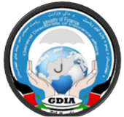 | General Directorate of Takaful and Insurance  Afghanistan

[Annual Report]
STABLE INSURANCE INDUSTRY. PROTECTED POLICYHOLDERS. SUSTAINED ECONOMIC GROWTH.

Contents
Message from the Director General 2
Afghanistan – Demographics and Macroeconomic Indicators 3
Section 1: About the General Directorate of Insurance Affairs (GDIA) 4
1.1 Background 4
GDIA’s Vision 4
GDIA’s Mission 4
1.2 GDIA’s role as the Insurance Regulator 4
1.3 Insurance Industry’s and GDIA’s Milestones 5
1.4 Overview of Insurance industry in Afghanistan 5
Section 2: Insurance Market Performance 9
Section 3: Insurance Companies in Afghanistan 14
3.1 The Afghanistan National Insurance Company (ANIC) 14
3.2 The Insurance Corporation of Afghanistan (ICA) 15
3.3 The Afghan Global Insurance (AGI) 16
3.4 The SKY Insurance 17
3.5 Analysis of the Financial Report of Sadra 18
19
3.6 Mellat Insurance 19
3.7 Razi Insurance 19
Section 4: Development Initiatives 20
4.1 Primary laws and legislation 20
4.2 Regulations 20
4.3 Regulatory Guidelines and Documents 20
4.4 Supervision and Enforcement systems 20
4.5 External affairs and public relation activities 21
4.6 Memorandums and Agreements 26
4.6.1 Foreign 26
4.6.1 Domestic 27
4.7 Other activities and functions performed by GDIA 27
Section 5: Achievements and Donor support 29
5.1 Support from the World Bank Group 29
5.2 Support from the Islamic Development Bank 29
5.3 Achievements 30
Section 6: Conclusion and Future Direction 31

Message from the Director General

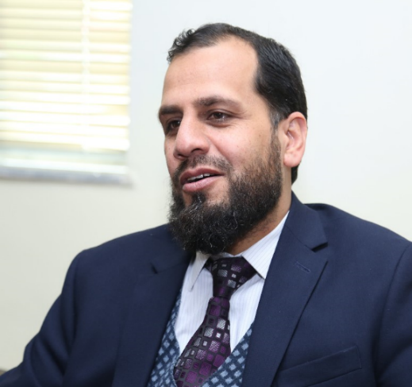
As the insurance helps in providing protection against financial risks to various segments the society and supports economic development, it also helps in providing protection to business and investment activities. The insurance industry, just like other parts of financial sector, remain crucial to providing and facilitating a secure and stable macroeconomic environment in the country.

In most of the developed as well as many developing economies, the contribution of insurance industry remains high as a percentage of their GDP. However, like other sectors of the economy, the insurance industry in Afghanistan remained underdeveloped due to instable political situation in last three decades. Now with the continuously improving political and economic situation, supported by the international community, the country’s business sectors are showing promising future, including the insurance industry.

At the General Directorate of Insurance Affairs (GDIA), under the leadership of the Ministry of Finance, we are striving to further develop the insurance industry and strengthen the protection of insurance policyholders. The GDIA has also initiated measures for the development of the insurance market through the better regulatory framework and suitable amendments in the insurance law, improved regulations and policies, and strengthening of supervisory practices.

During last few years, the GDIA has also carried out insurance market development activities and public awareness programs across the country to educate the mass public and enhance insurance literacy. GDIA has also successfully established bilateral relationships and cooperation with various insurance regulators in other countries. With its continued efforts, the GDIA has been recognized by the World Bank in its validation exercise as one of the top performers in attainment of the strategic goals.

The GDIA remain grateful to the Ministry of Finance for its continued encouragement and support. It also remains thankful to its donors and development partners for helping out in the development of the insurance sector and achieving the strategic objectives. GDIA remains committed to continue efforts to foster a well-developed and stable insurance market, where policyholders are protected and transparent market practices result in flourishing economic development.

Mohammad Musa Kamawi
Director General
General Directorate of Insurance Affairs

Afghanistan – Demographics and Macroeconomic Indicators

Country Afghanistan
Capital Kabul
Population 32,500,000
Area 652,864 square kilometers (252,072 square miles)
Density 49.88 per square kilometer
Currency Afghani (USD 1 is equal to AFG 75) as of May 2020
GDP per Capita USD 572 (2018 data)
Insurance penetration 0.001% (2018 data)
Export USD 0.88 billion (2018)
Import USD 7.41 billion (2018)
Balance of Trade USD (5.13) billion (2018)

Figure 1: Map of Afghanistan
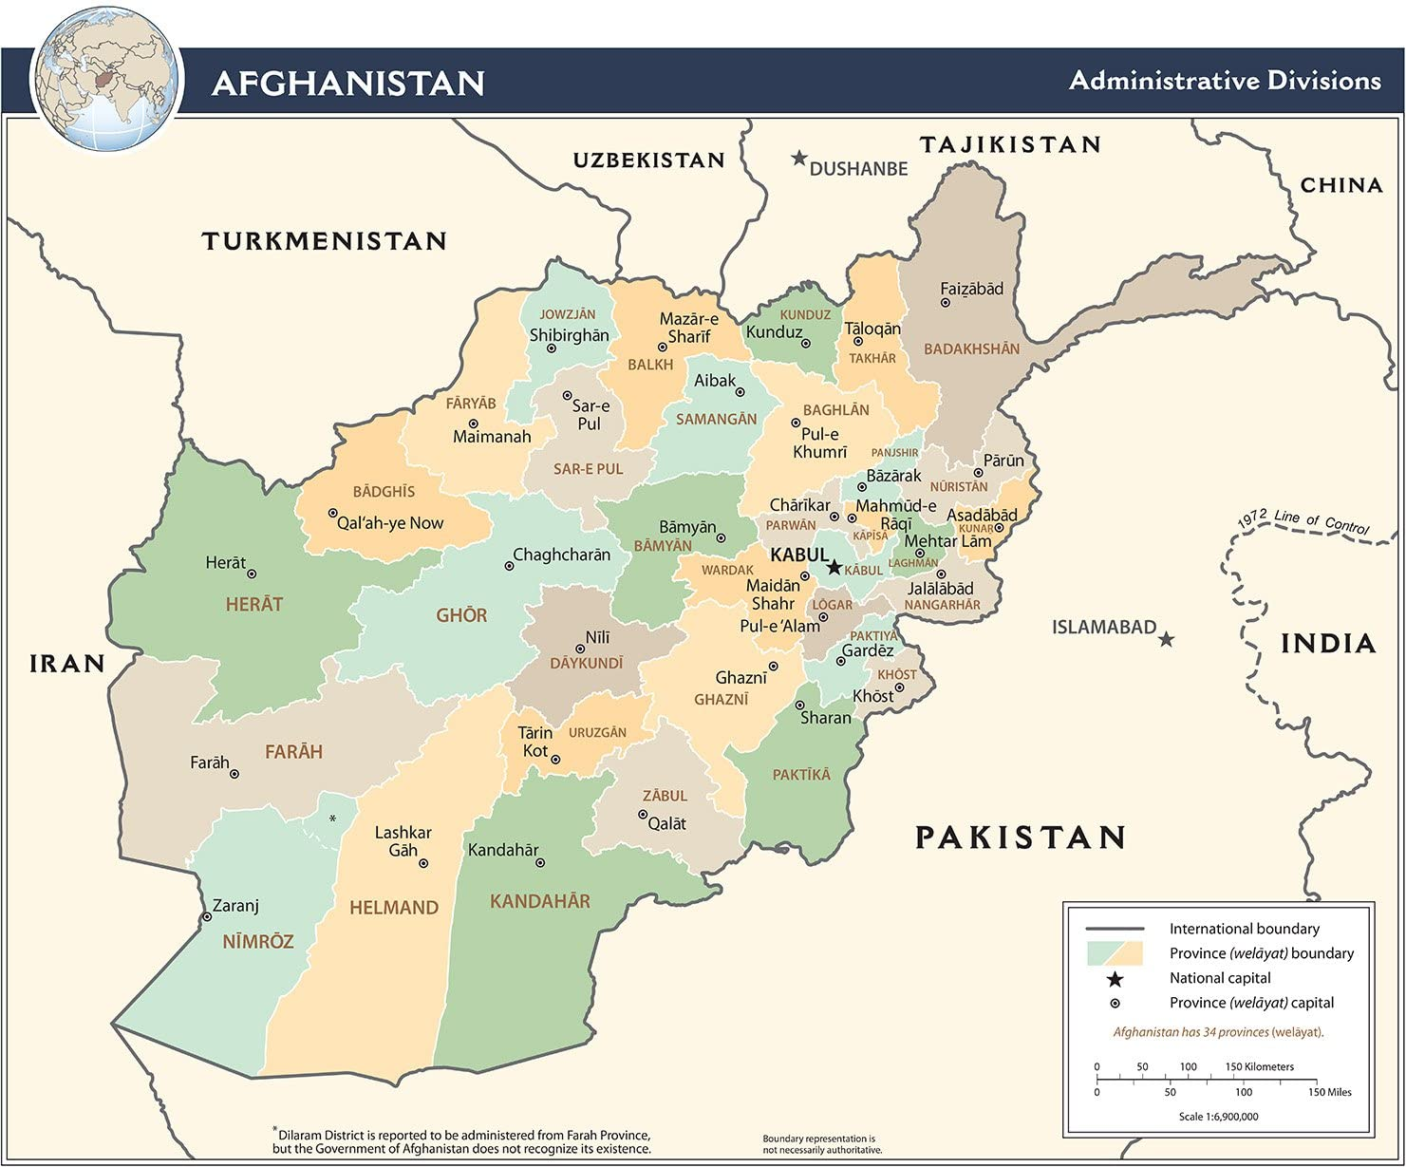

Section 1: About the General Directorate of Insurance Affairs (GDIA)

1.1 Background

The General Directorate of Insurance Affairs (GDIA), formerly the Afghanistan Insurance Authority (AIA), was established under the aegis of the Ministry of Finance in 2005 for carrying out the licensing, market development activities, formulations of related laws and regulation, and for promoting the insurance activities in the country. In 2017, the AIA was formally designated as the GDIA.

Since its inception, the GDIA has been actively carrying out its regulatory and supervisory activities, in terms of issuing licenses, organizational development, establishing insurance board, developing different laws and regulations, initiating public awareness programs, efforts in capacity building and reforms, preventing insurance illegalities and creating cooperative understandings with foreign counterparts.

GDIA’s Vision

To create a stable, developed, strong and financially independent economy in the country through a well-developed insurance sector.

GDIA’s Mission

GDIA is committed to achieve, a secure economic and social live and inner peace for all, with a developed, quality and appropriate insurance industry, an aware citizens regarding insurance service and its significance, a rich insurance sector from foreign and domestic private investment and an accessible and simple insurance system, which address the insurance-based demands.

1.2 GDIA’s role as the Insurance Regulator

The GDIA, as a regulating body under the umbrella of Ministry of Finance, is the only government institution assigned to regulate, supervise and develop the insurance sector in Afghanistan. It aims at facilitating the public and private entrepreneurship to invest in insurance sector, improve customer awareness and protection, enhancing stability and market effectiveness through regulation and supervision, and development of required rules and laws.

1.3 Insurance Industry’s and GDIA’s Milestones

- 1964: First insurance company established in Afghanistan, namely the Afghan Insurance Corporation (AIC);
- 2001: Due to domestic conflicts, the insurance industry did not have any operation until the end of 2001 and the conclusion of Taliban regime;
- 2007: Private investment started in the country with the establishment of Afghanistan Insurance Corporation (ICA);
- 2008: As per the direction of the Ministerial Council, the Afghanistan Insurance Authority (AIA) was established under the umbrella of the Ministry of Finance.
- 2017: As per the order of H.E the President of the Islamic Republic of Afghanistan, the AIA was upgraded to become the General Directorate of Insurance Affairs (GDIA), as the first grade under the Deputy Minister for Administration of Ministry of Finance;
- 2018: The amendment process in the existing insurance law started, while taking into account the Insurance Core Principles (ICPs) of the International Association of Insurance Supervisors;
- 2019: The development of Takaful (Islamic Insurance) legal and regulatory framework was started, which has now been submitted along with the amended insurance law to the Ministry of Justice.

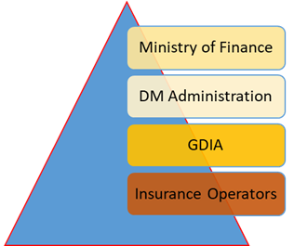

Figure 2: Hierarchy of insurance regulatory and industry entities

1.4 Overview of Insurance industry in Afghanistan

Afghanistan is an agriculture-based economy, which suffers from a relatively underdeveloped infrastructure and business environment. There are currently five domestic insurance companies operating in Afghanistan, including one public and four privately held insurers. The state-owned Afghan National Insurance Corporation (ANIC) was established in 1964, while Insurance Corporation of Afghanistan (ICA) in 2007, the Afghan Global Insurance (AGI) in 2010, and the Sky Insurance in 2016, and the Sadra Insurance in 2018. Further, there are two branches of foreign insurance companies, both from Iran, namely the Razi Insurance Agent and the Mellat Insurance Agent, which are also operating in the country but limited only to the business of travel insurance.

These all are non-life (general) insurance companies and are currently providing nearly 30 types of non-life insurance products across the country, including the health insurance, aviation, personal accident, fire, travel, and motor insurance. At present, there are no insurers in the country providing the life insurance products.

Figure 3: Market Share of Top Five Insurance Products in Afghanistan (in percentages)

Table 1: Market Share of Top Five Insurance Products in Afghanistan
 | 2017 | 2018 | 2019
 | % | % | %
Travel Insurance | 45.64 | 88.9 | 62.21
Motor Third Party Insurance | 0 | 0 | 26.57
Fleet Motor Insurance | 10.77 | 7.05 | 5.52
Project Third Party Liability | 0 | 3.47 | 4.39
Aviation | 0 | 0.12 | 0.76

At present, there is no local reinsurance company domiciled in Afghanistan. It has been observed that a significant portion of the gross written premium is ceded to foreign reinsurers, while only a small percentage of premiums is retained in the country, owing to the limited financial and risk capacity of insurance companies.

Up until 2018, the insurance sector has mostly remained concentrated in the central parts of Afghanistan, amounting to a market share of approximately 65%, while there has been a limited outreach and penetration in to other regions. According to the information presented by the GDIA, the insurers have operations across 24 out of 34 provinces.

Figure 4: Concentration of policyholders in different regions

Table 2: Number of Insurance Policyholders in Afghanistan
 | 2016 | 2017 | 2018 | 2019
Regions
Centre | 397 | 474 | 564 | 19,043
North | 4,560 | 1,673 | 5,392 | 4,422
South | 141 | 39 | 3,325 | 426
East | 1,181 | 3,222 | 3,126 | 5,183
West | 622 | 23,093 | 6,863 | 8,143
Total | 6,901 | 28,501 | 19,270 | 37,217
Growth rate |  | 313% | -32% | 93%

The table above shows significant variation in increase and decrease in the number of policyholders in different regions across the country, during last three years. The year 2016-17 remained economically successful for most of the businesses in the country. The government also introduced initiatives, especially for the private sector, in terms of facilitating investment and opportunities. Also, insurance services have been promoted across all sectors, especially in health, fire, personal accident, cargo, etc.

On the other side, 2018 remained slow for all business and insurance sector was also affected. Withdrawal of foreign forces, decrease in international projects requiring insurance coverage, the increased insecurity and unstable political situation, increased taxes and tariffs, along with the change of import routes from Karachi port to Chah Bahar port caused business delays and slowdown, eventually resulting in the regional shift in the distribution of the number of insurance policyholders.

As compared to 2018, the year 2019 showed increase in the number of policyholders in the central region and other provinces of the country, by 93%. This increase has been possibly due to many factors, including:

- Requirement of having the compulsory fire insurance by the government for all properties titled commercial and all businesses to attain fire insurance before applying for new establishment and or renewal purpose;

- Increased travels to countries where travel insurance is necessary like Iran, Turkey, etc.

- Increased volume of imports requiring cargo, fleet, and goods insurance;

Although the total industry’s gross insurance premium in Afghanistan remains very low, even if compared with the developing countries in the region, it is showing encouraging signs of growth. Just between 2018 and 2019, the insurance industry total gross written premium grew by a whopping 154% from USD 13.7 million to USD 34.79 million.

Table 3: GDP, Premium, and Insurance Penetration in Afghanistan
Year | GDP  (USD billion) | Premium  (USD million) | Insurance Penetration  (% of GDP) | Year-on-year Growth  (%)
2017 | 19.70 | 13.63 | 0.00069 | -
2018 | 20.20 | 13.70 | 0.00067 | 1%
2019 | 19.90 | 34.79 | 0.0017 | 154%

Section 2: Insurance Market Performance

As mentioned earlier, there are currently five insurance companies operating in Afghanistan, including four in the private sector and one in the public. The local and fully licensed insurance companies are:

- The state owned Afghan National Insurance Corporation (ANIC) – established in 1964,
- Insurance Corporation of Afghanistan (ICA) – established in 2007,
- Afghan Global Insurance (AGI) – established in 2010,
- Sky Insurance – established in 2016, and
- Sadra Insurance – established in 2018.

These insurance companies are currently providing around 30 types of insurance products across the country. Health insurance, aviation, personal accident, fire, travel, and motor insurance are seen to be some of the most prominent classes of insurance in the local market.

Despite the fact that there is a sizeable potential insurance market in the country, the presence of insurance companies and use of insurance services is low. In 2019, the insurance sector remained mostly (approximately 65%) concentrated in the central region of Afghanistan and mainly the capital city, with limited outreach and penetration in the outer regions.

Although, the insurers tend to show having operations across 24 provinces and in some border areas of the country. Currently, none of the insurers in Afghanistan is licensed to provide the life insurance product. This is largely due to various influencing factors, such as the lack of public awareness about insurance, the political instability, and possibly due to non-preference of insurance by some segments of society considering insurance as against their Islamic beliefs.

The following figure shows the consolidated financial position of country’s insurance sector during last four years.

Figure 5: Financial Performance of Insurance Industry in Afghanistan

Table 4: Key Financial data of the insurance sector
(in USD millions) | 2015 | 2016 | 2017 | 2018
Total assets | 26.61 | 27.19 | 27.19 | 28.02
Growth rate |  | 2% | 0% | 3%
Total equity | 20.48 | 19.46 | 20.40 | 20.56
Growth rate |  | -5% | 5% | 1%
Total liabilities | 8.93 | 10.53 | 9.60 | 10.27
Growth rate |  | 18% | -9% | 7%

The total assets of the insurance industry in Afghanistan have increased from USD 26.61 million in 2015 to USD 28.02 million in 2018, with an annual increase of 3% in 2017-18.

Figure 6: Insurance Industry Performance Indicators in Afghanistan

Table 5: Key indicators of insurance industry in Afghanistan
(in USD millions) | 2015 | 2016 | 2017 | 2018
Gross Premium | 9.59 | 12.91 | 12.16 | 16.54
Growth rate |  | 35% | -6% | 36%
Premium retained | 2.82 | 3.39 | 4.21 | 4.85
Growth rate |  | 20% | 24% | 15%
Paid to reinsurer | 7.70 | 10.46 | 8.88 | 12.61
Growth rate |  | 36% | -15% | 42%
Claims paid | 1.55 | 1.02 | 1.82 | 1.47
Growth rate |  | -34% | 78% | -19%

The total Gross Premium of the insurance industry in Afghanistan has increased to almost double from USD 9.59 million in 2015 to USD 16.55 million in 2018, with an annual increase of 36% in 2017-18.

Similarly, the total Premium retained by the insurance industry in Afghanistan has increased to almost double from USD 2.82 million in 2015 to USD 4.85 million in 2018, with an annual increase of 15% in 2017-18.

Table 6: Industry-wide Premium Retention and Reinsurance ratios
 | 2015 | 2016 | 2017 | 2018
Gross Premium | 9.59 | 12.91 | 12.16 | 16.54
Premium retained | 2.82 | 3.39 | 4.21 | 4.85
Retention Ratio | 29% | 26% | 35% | 29%
Paid to reinsurer | 7.70 | 10.46 | 8.88 | 12.61
Reinsurance Ratio | 80% | 81% | 73% | 76%

There has been a slight improvement in the retention ratio by the insurance industry in Afghanistan, whereby the retention ratio has increased 26% in 2015 to 29% in 2018. This shows that the local insurance companies are retaining more risk locally than passing it on to the foreign reinsurers. The GDIA will continue to encourage local insurers to increase their financial capacity, hence increasing their local risk retention capacity.

Table 7: Performance Ratios of the Insurance Industry in Afghanistan
 | 2015 | 2016 | 2017 | 2018
Total assets | 26.61 | 27.19 | 27.19 | 28.02
Gross Premium | 9.59 | 12.91 | 12.16 | 16.54
Total Assets to Premium Ratio | 36% | 47% | 45% | 59%
Total equity | 20.48 | 19.46 | 20.40 | 20.56
Profit before tax | 0.13 | 0.50 | 0.57 | -0.22
Total Assets to Premium Ratio | 1% | 3% | 3% | -1%
Gross Premium | 9.59 | 12.91 | 12.16 | 16.54
Profit before tax | 0.13 | 0.50 | 0.57 | -0.22
Profitability Ratio | 1% | 4% | 5% | -1%
Gross Premium | 9.59 | 12.91 | 12.16 | 16.54
Claims paid | 1.55 | 1.02 | 1.82 | 1.47
Claims Ratio | 16% | 8% | 15% | 9%
Gross Premium | 9.59 | 12.91 | 12.16 | 16.54
Premium retained | 2.82 | 3.39 | 4.21 | 4.85
Retention Ratio | 29% | 26% | 35% | 29%
Gross Premium | 9.59 | 12.91 | 12.16 | 16.54
Ceded to reinsurer | 7.70 | 10.46 | 8.88 | 12.61
Cession Ratio | 80% | 81% | 73% | 76%

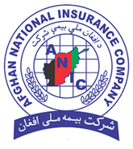
Section 3: Insurance Companies in Afghanistan

3.1 The Afghanistan National Insurance Company (ANIC)

Founded in 1964, Afghan National Insurance Company (ANIC) is the oldest insurance company in the country with an experience of more than half a century of insurance services provision. ANIC is a state-owned corporation, which is a prominent revenue-generating business organization for the Afghan government, and benefits the country by providing insurance services to public, as well as offering the business profitability to the state.

Some of the insurance products offered by ANIC include:

- Health Insurance
- Comprehensive Vehicle Insurance
- Third-party Vehicle Insurance
- Travel Insurance
- Fire Insurance
- Aviation Insurance
- Cargo Insurance
- Personal Accidents’ Insurance
- Students Insurance
- Employees Accidents’ Insurance

It is reported that ANIC has offices in various provinces, including not just the Kabul, but also in Balkh, Herat, Kandahar, Nangarhar, Baghlan, Khost, Samangan, Pansher, Kapisa, Parwan, Laghman, Loger, Sar-e-pul, Faryab, JowzJan, Kunduz, Faryab, Paktya and Badghis.

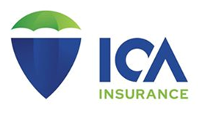

3.2 The Insurance Corporation of Afghanistan (ICA)

The Insurance Corporation of Afghanistan (ICA) was established in 2007 in response to the demand for an officially licensed and adequately capitalized private multi-line insurance company, meeting the insurance needs of customers in the country.

ICA offers a comprehensive range of commercial insurance solutions, providing business risk protection for multi-national and Afghan companies in key economic sectors. ICA has reported to have reinsurance support from international reinsurance companies. The insurance products offered by ICA include:

- Aviation insurance
- Cargo insurance
- Construction insurance
- Defense Based Act insurance (DBA)
- Personal Accident insurance (PA)
- Professional Indemnity
- Property Business interruption insurance
- Political Risk insurance
- General third party liability insurance
- Banker’s blanked bond insurance
- Employees liability insurance
- Fleet Motor Insurance
- Health insurance
- Travel Insurance

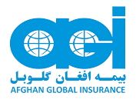

3.3 The Afghan Global Insurance (AGI)

Afghan Global Insurance (AGI), launched in 2010, is a general insurance provider, offering a variety of policies to private sector, government, NGO’s and individuals throughout Afghanistan with offering a complete range of general insurance products. The range of insurance products offered by AGI include:

- Health insurance
- Group personal Accident insurance
- Workmen compensation insurance
- Construction all Risk insurance
- Motor Insurance
- Travel insurance
- Fire insurance
- Defense Based Act violation insurance
- Erection all Risk insurance
- Banker’s blanked bond insurance
- Aviation insurance
- Professional Indemnity insurance
- Cargo insurance
- Defense Based Act insurance DBA

3.4 The SKY Insurance

Sky international insurance was incorporated in September 2016. It offers insurance products including:

- Aviation Insurance
- Marine cargo insurance
- Contractor’s all risk (CAR)
- Group personal accident (GPA)
- Worker compensation (WC)
- Defense based act (DBA)
- Property and casualty insurance
- Banker blanket bond (BBB)
- Travel Insurance
- Motor fleet insurance
- Liabilities insurance
- Fire Insurance

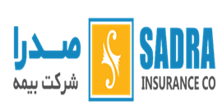

3.5 Analysis of the Financial Report of Sadra

Sadra insurance company is one of the private insurance companies in Afghanistan, registered since 2018. The stocks of this Company are entirely in ownership of individuals and non-governmental entities. Insurance services of the company can be classified into following products:

- Fire property.
- Travel insurance
- Employer’s liability
- Others

The Company started its operations in only in late 2018.

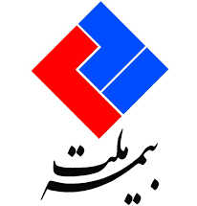

3.6 Mellat Insurance

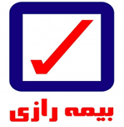
Mellat Insurance Company (Afghan Representative) has been registered with GDIA since November 2016. The company has a representative office for travel insurance services in 4 provinces including Kabul, Nangarhar (Jalalabad), Balkh (Mazar-e Sharif), Herat (Herat Center), and Kandahar (Kandahar Center).

3.7 Razi Insurance

Razi Insurance Company (Afghan Representative) has been registered with GDIA since January 2017. The Company has a representative office for travel insurance services in 5 provinces including Kabul, Nangarhar (Jalalabad), Balkh (Mazar-e Sharif), Herat (Herat Center), Kandahar (Kandahar Center). The Company offers travel insurance services to improve the travel of citizens. Passengers traveling to the neighboring countries such as Iran can benefit from this coverage by purchasing a travel insurance policy.

Section 4: Development Initiatives

4.1 Primary laws and legislation

Recently, the GDIA has taken certain important measures for strengthening and upgrading of the legal framework for insurance industry in Afghanistan. The review of the draft new insurance law has been carried out jointly with the Ministry of Justice. For consultation purpose, and to ensure everyone is on the same page with GDIA for the developed documents, moreover get feedback on the laws and regulations, a joint stakeholders’ workshop was organized and the documents, new amended insurance law and related regulations along with the draft of Takaful assessed and reviewed. Rationales for proposed changes broadly discussed for enrichment of the laws and regulations.

4.2 Regulations

Various regulations have been prepared and soon ready to be implemented. These include the regulations for:

- Fire insurance
- Motor third party liability insurance
- Health insurance
- Micro insurance (for low-income population)
- Insurance Solvency
- Corporate Governance
- Fit and Proper (Management of Insurance companies)

4.3 Regulatory Guidelines and Documents

In addition to the above, various other documents have also been prepared, including the:

- Article of Association for handicraftsmen
- Migrant insurance regulation
- Solvency regime
- Commission and agent regulation
- Licensing regulation
- Procedure and tariff for third party liability
- Procedure and tariff for fire insurance

4.4 Supervision and Enforcement systems

In addition to the above, various other documents have also been prepared, including the:

- Offsite examination process manual
- Financial and ratio analysis tools
- Onsite inspection process manual
- Quarterly financial reporting standards

4.5 External affairs and public relation activities

Meanwhile, for raising feedback of stakeholders to enrich and to strengthen the legal framework and also for awareness purpose, the GDIA has undertaken and conducted gatherings, workshops and seminars at different stages and numerous locations during the past year, which were quite helpful for the sector development. We shed light over some of these events as follow:

Meeting with the Deputy Minister for Ministry of Justice Mr. Mohammad Qasim Halimi for discussion over the review progress and acceleration of draft Takaful law. | 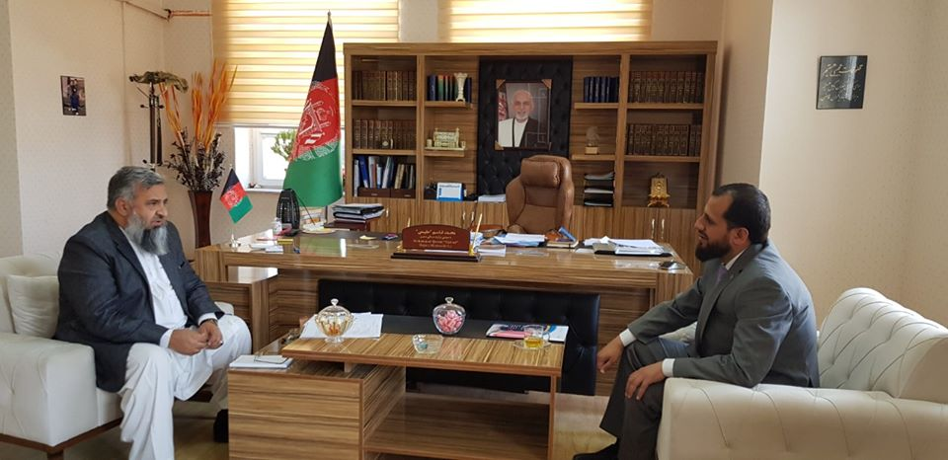
A two-day workshop organized in Kabul with the World Bank experts for discussion over the items including:  - Review of the amended insurance law articles as per the Insurance Core Principles;  - Article-wise review of the Takaful law; and  - Providing feedback on how to strengthen and standardize insurance supervision. | 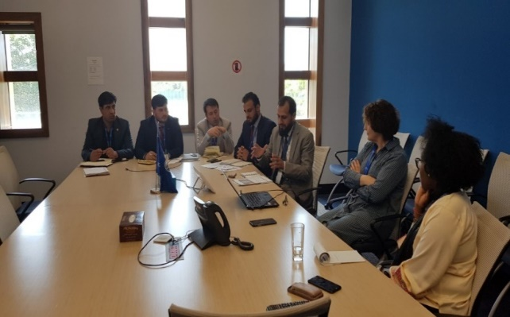
A workshop was organized on execution and implementation of the ministerial council decree No.39 on fire insurance. Representatives from 35 sectoral departments responsible for licensing and supervision, including the Ministry of commerce and industries and public and private insurance companies attended the workshop. | 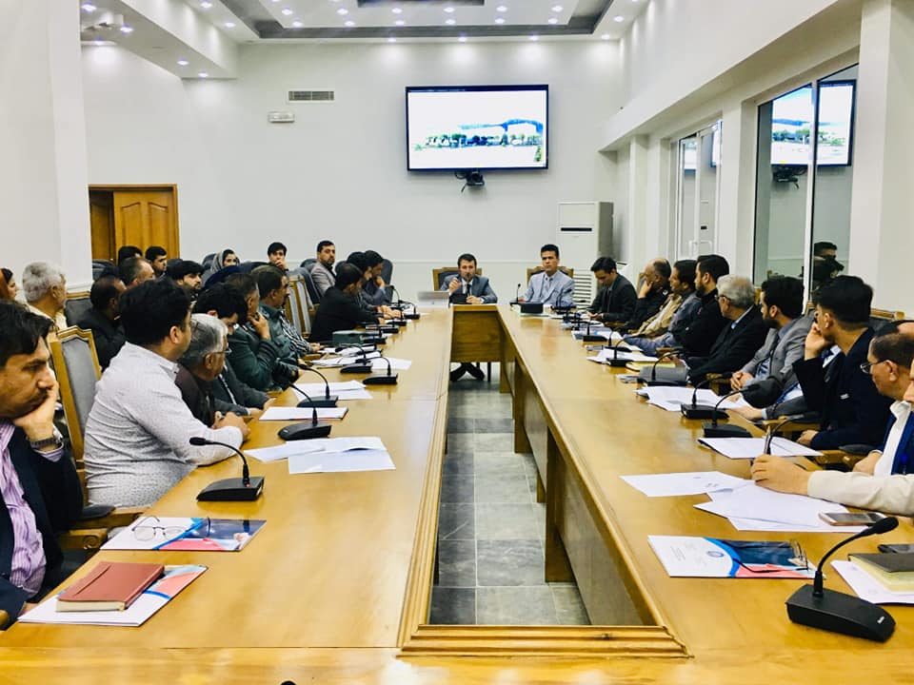
Meeting with Kabul municipality for cooperation on implementation of fire insurance and urging businesses licensed by Kabul Municipality to obtain fire insurance for their establishment as deemed required. | 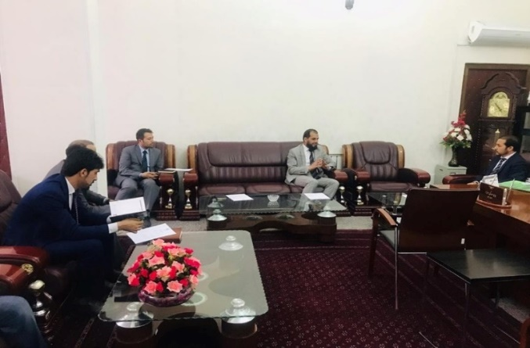
Meeting the National Office of Preparedness and Combating Disaster head of coordination for mine clearance on consolidating efforts between the two sectors in light of use of insurance services and products. | 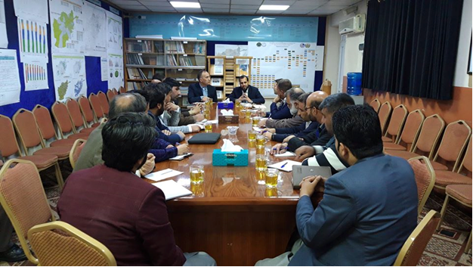
Meeting with the Second political division of  Ministry of Foreign Affairs (MoFA) in order to  establish bilateral cooperation with regional  insurance departments. | 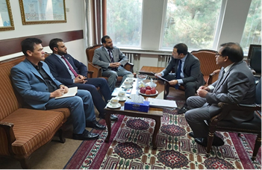
Meeting with Central Insurance of Islamic Republic of Iran with the aim of developing bilateral cooperation in the field of insurance by exchanging experiences and sharing insurance information, launching capacity building programs, addressing existing insurance problems between the two countries, providing the necessary facilities for Afghan entrepreneurs to invest and insure activities in the territory of Iran. | 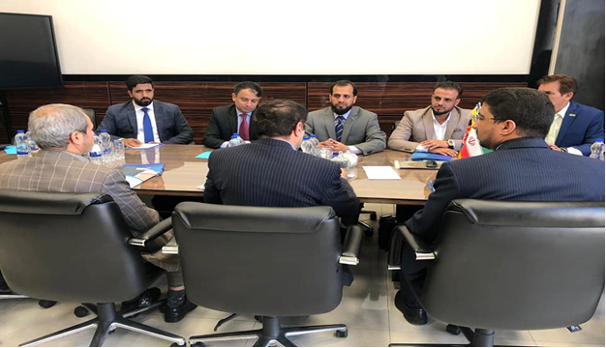
Workshops with stakeholders and relevant departments for obtaining feedback on Offsite and Onsite inspection manuals and guideline for licensing procedure. | 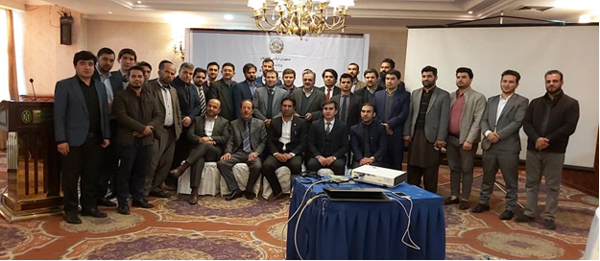
Public awareness programs  As part of responsibilities on shoulders of GDIA is enhancing insurance literature and making the public aware of benefits of insurance, the GDIA has conducted numerous workshops for stakeholders, government entities, educational sector, traders and other sectors in Kabul and major cities of Kandahar, Mazar, Herat and Nangarhar provinces. Some are highlighted below;  - At the DMC mine clearance  - For the private-owned universities  - For the Kabul Municipality  - For the Ariana Afghan Airline Directorate  - At the Central Bank  - At the Afghanistan Banks Association for the banking sector  - At the Afghanistan Chamber of Commerce and Industries (ACCI) and  - At Ministry of Transport | 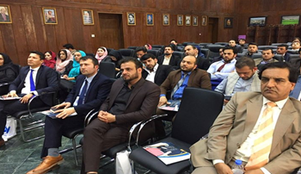  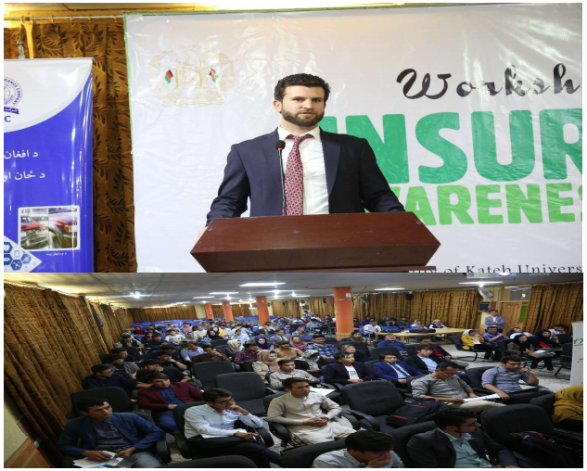  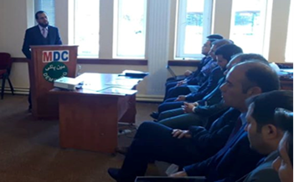
Public Disclosure  First time public disclosure of reforms, activities performed and achievements of GDIA through government media and information center in the presence of Deputy Minister of Finance for Administration Mr. Habib Zadran. | 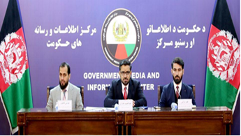
First introductory conference on Takaful (Islamic Insurance) at Intercontinental Hotel. The conference was attended by different stakeholders, members of the Ulema Council, representatives of the Islamic Development Bank, chambers of commerce, state and non-government insurance companies, presidents and representatives of various government departments. | 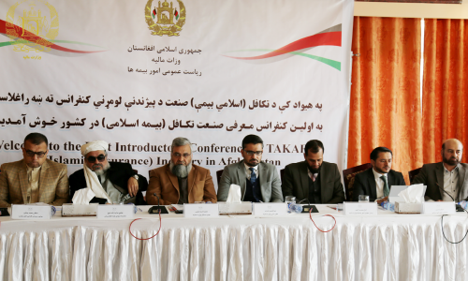
Conference on Takaful introduction in Herat province with the participation of high-ranking officials of Herat province, elites, university professors, representatives of commerce and industry and mining chambers, businesspersons and entrepreneurs of the province and senior employees of the General Directorate of Insurance Affairs of the Ministry of Finance held at Sadaf International Hotel. The purpose of holding this conference was to raise awareness and introduce the legal framework of Islamic insurance in the country and to encourage investment in the Takaful industry. | 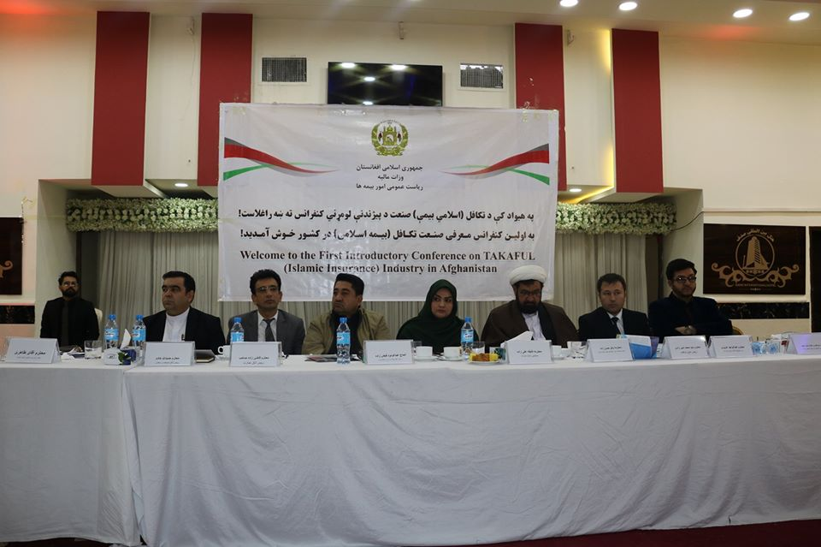
Conference on Takaful held in Jalalabad with participation of high-ranking officials of Nangarhar province, elites, professors of law and economics faculty of Nangarhar University, representatives of chambers of commerce and industries, entrepreneurs and pioneers of the province and senior employees of the General Directorate of Insurance Affairs at the conference hall of Nangarhar province to raise awareness and encourage investment in the Takaful industry. | 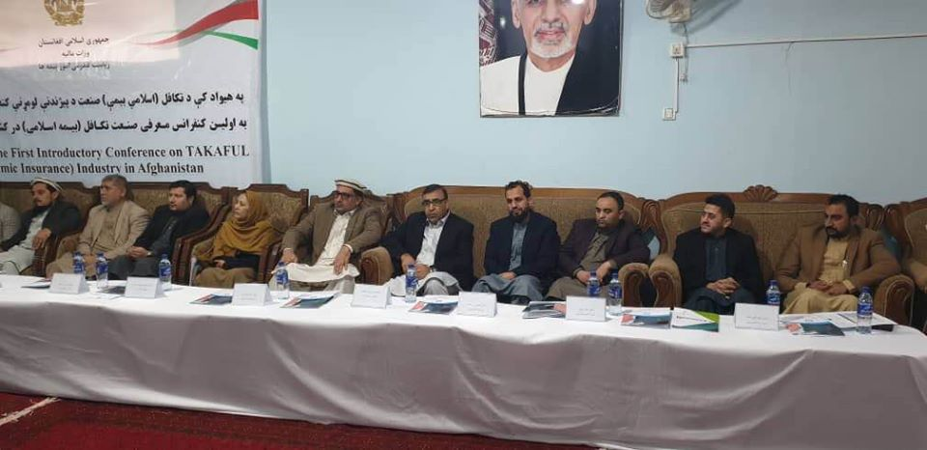

4.6 Memorandums and Agreements

4.6.1 Foreign

- A Memorandum of Understanding has been signed with the Turkey’s General Directorate of Insurance (GDI) for the purpose of cooperation and exchange of information between the two regulators, conducting joint efforts in a framework that would result in mutual cooperation, increased mutual understanding, exchange of information and technical cooperation to the extent permitted by law, regulations and authorized requirements. It also included the transfer of knowledge by means of providing training programs in the host country and participation in internship programs with a focus on education, preparation of training materials.

- Also, the minutes for Memorandum of Understanding have been signed with the Islamic Republic of Iran’s Central Insurance for developing bilateral cooperation in the field of insurance by exchanging experiences and sharing insurance information, launching capacity building programs, addressing existing insurance problems between the two countries, providing the necessary facilities for Afghan entrepreneurs to invest and insure activities in the territory of Iran.

- A Memorandum of Understanding has also been signed with the Tajikistan’s Insurance Regulatory body (Seghorta) for mutual cooperation and facilitating the trade between the two nations.

- A Memorandum of Understanding has been signed with the Chesterfield Lloyds of London’s insurance broker for the purpose of ensuring transparent activities of insurance companies in order to create beneficial cooperation and exchange of necessary information for monitoring, management and growth of insurance activities in accordance with international principles and standards.

4.6.1 Domestic

- A Memorandum of Understanding has been signed with the General Directorate of the central registry and intellectual properties of the Ministry of Commerce and Industries for the purpose to determine the rights and obligations of the parties and to create and activate a representative desk of GDIA under the umbrella of the Central Registry Office and the Ministry of Commerce and Industries to facilitate license issuance process.

- A Memorandum of Understanding has been signed between the General Directorate of Insurance Affairs of the Ministry of Finance and the Directorate of Export promotion, the Legal Directorate and the Directorate of Exhibitions of the Ministry of Trade and Industry. This memorandum is aimed at ensuring continuous engagement and professional relations, efficiency and strengthening multilateral cooperation for the development of the insurance, trade and domestic industries sectors.

- A Memorandum of Understanding has been signed with the Faculty of Economics of the Kabul University for including insurance in the curriculum and to provide required transfer of knowledge to the new graduates on insurance.

- A Memorandum of Understanding has been signed with the Da Afghanistan Bank (DAB) for the purpose of sharing information, knowledge and experiences specifically in supervision department and to facilitate educational programs to GDIA as and when required.

4.7 Other activities and functions performed by GDIA

- Controlling fraud and illegal activities: Since protecting the rights of customers, as well as the insurance operators is one of the main duties of the General Directorate of Insurance being the insurance sector’s regulator, it has been working to encounter any potential illegal activity, especially in the health and travel insurance business in Afghanistan. The legal violations department at GDIA has performed its duties and activities by preventing illegal insurance activities and violations. It has also been investigating the complaints and issues raised by the insurance customers in accordance with the provisions of the insurance law. During the course of the year, 15 different legal cases bearing violation and complaints were reported by the supervision team and subsequently documented by the violations department for each of which timely actions were carried out for redresses. These cases varied in nature as illegal sale of insurance product, non-compensation by the insurance companies, insurance operators non-reporting and delayed reporting of financials, monopolistic acts and complaints at customs.

- Audit and inspection of insurance companies: The GDIA regularly carries out the audited and onsite inspections of the insurance companies.

- License issuance and renewals: Throughout the year, the existing licenses of insurance entities are renewed, while occasionally new licenses are also issued by GDIA after the completion of all legal requirements. Licenses for two new entrants have been issued (M/s Sadra Insurance Co. & M/s Capital Star Insurance Co.)

- Development of quarterly and annual reporting: The ongoing supervision activities result in the preparation and compilation of quarterly and annually supervisory reports.

- Capacity building of supervisory staff: Various training and capacity building measures have been taken throughout the year. These include the training of the regulatory and supervisory staff in the areas of offsite financial analysis and examination of insurance companies, the onsite inspections, implementing insurance Solvency regime, the Takaful, among other topics. Some of these training were carried out inside Afghanistan, while other were conducted overseas in places, such as UAE and Turkey.

- Creating insurance education and awareness: The GDIA also carried out at least four public education and awareness workshops at the Central bank, the Kabul municipality, the Ministry of Mines and Petroleum, and the Ministry of Transport.

- Development of GDIA’s file, brochures and logo: New designs of GDIA’s files, brochures, and logo have been prepared, which are now at the bidding stage in the procurement department. Once finalized, these will be available shortly.

- Documentary videos clip for creating insurance awareness: GDIA is in the process of preparing the documentary videos clips for creating insurance awareness in the country. These will be prepared in the local language, with content which will be aimed at people with low literacy levels. It is expected that such documentary video clips will help in creating more awareness about insurance products in the country.

- Insurance billboards: Insurance signage and billboards have been set up in Kabul and four other provinces, with an objective of creating public awareness about insurance services.

- Other important measures: Various other important measures have also been taken or are in the due process. These include updating the GDIA’s five year rolling plan on Afghanistan performance Management information system APMIS, the drafting of the National Risk assessment report including insurance sector, and development and implementation of the insurance database for recording the key financial data.

Section 5: Achievements and Donor support

The GDIA remains committed to achieving the secure economic and social environment in the country with the help of sound insurance industry, aiming to provide access to suitable and affordable insurance products to the people of country and to achieve these strategic goals and objectives. Under the guidance of the Ministry of Finance, GDIA has been able to receive cooperation from the international institutions, such as the World Bank and the Islamic Development Bank (IDB).

5.1 Support from the World Bank Group

The World Bank Group has been supporting the Ministry of Finance under the project Fiscal Support Program (FSP). Under this program, the GDIA was also provided support in terms of developmental budget and to achieve its strategic objectives.

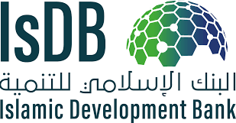

5.2 Support from the Islamic Development Bank

To develop the Takaful law and regulatory framework and to support the development of Islamic insurance market in the country, the government of Afghanistan has been provided support by the Islamic Development Bank (IDB). This support by IDB resulted in the development of legal and regulatory framework of Takaful. Currently, the draft law is under process at the Ministry of Justice.

5.4 Achievements

The 2018 Performance Evaluation (1st Grade) was carried out by the World Bank, which is one of the prominent development partner of the government of Afghanistan in terms of providing budgetary support to line ministries under its Fiscal Support Program (FSP). Each year, teams under the FSP program would provide their respective plans. These plans are accordingly reviewed and assessed thoroughly by the experts from the World Bank. When the planned objectives are justified as to what extent, these would result in reforms, the next step is the approval allocation of budget. The annual performance of each department is then reviewed before close of the fiscal year by the validation team and activities are scored based on certain scoring criteria. The Director General-level grading is done considering the grades received by the Directorates and Sub-directorates.

The GDIA secured the top position under all scenarios, scoring a total of 74 per cent reflecting an outstanding performance in all dimensions.

Section 6: Conclusion and Future Direction

Although the size of insurance industry is small in Afghanistan but it is showing signs of growth and development. Also, there are certain priority areas where GDIA is considering to take initiatives, and which are also expected to help in development of the insurance industry in Afghanistan. Such policy initiatives are expected to not only strengthen the regulatory and supervisory practices, but also provide the industry with a well-defined roadmap for growth, financial stability, and sound competition. Some of these policy initiatives include:

- Development and implementation of an upgraded and comprehensive insurance law, in line with international standards and best practices;
- Introduction of sound financial standards and insurance solvency regime;
- Promotion and development of Islamic alternative to insurance (Takaful);
- Microinsurance market development to create access to insurance for low-income people;
- Development of supervision and enforcement tools/ manuals for supervisory staff;
- Training and capacity building of supervisory staff in the important areas of Supervision, Enforcement, Reinsurance, Financial Analysis, On-Site and Off-Site Inspections; and
- Development and execution of insurance education and awareness programs.

GDIA is also closely monitoring the financial indicators not just at the industry level but also at the individual level of an insurance company. If an insurance company has shown signs of stagnant or negative growth in last year, the GDIA has taken up the matter with the insurance company, directing it to take corrective measures and ensure that while the interest of the policyholders is protected, the financial stability and viability of the company is also secured.

GDIA has been encouraging insurance companies to increase their financial capacity that will result in their ability to retain more risk and more premium in the country, rather passing it on to the foreign reinsurers. For this purpose, GDIA is in the advance stages of developing and implementing the solvency regulations, which will help in ensuring that the insurance company possesses required level of financial capital at all times which is necessary to serve the policyholder liabilities.

The pursuance of this strategic future direction is expected to help in contributing to the development of the insurance sector in Afghanistan, thus contributing to the economic growth in the country.

Insurance penetration is the ratio of total insurance industry’s gross written premium to the country’s GDP. It is represented in percentage.

