CONSULTATION ON REFORMS TRACKING WEBSITE HOSTED BY DEPUTY MINISTER FOR POLICY
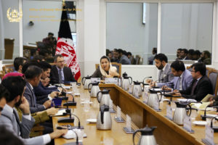
October 17, 2018
Deputy Minister of Finance for Policy Naheed Sarabi chaired a consultative meeting on Monday, October 15 at the Ministry of Finance’s Khyber Hall to introduce a new website that tracks reforms across government.
The Deputy Minister introduced the reforms tracking website, reforms.gov.af, and discussed its importance and purpose. The website is a consolidated platform that tracks government reforms deliverables across the ministries, and will be regularly updated and maintained.
Director General of Monitoring, Analysis and Reporting, Sajed Taqwa, presented the website to the participants and demonstrated how it functions. Participants included deputy ministers, directors, and public relations specialists from a range of ministries and government institutions.
The participants shared their comments and feedback on the website, in preparation for a public launch on November 8 at the Senior Officials Meeting in Geneva of the English language version of the website. The website is currently being translated into Dari and Pashto and will launch in local languages in the coming weeks.
The tracker shows progress made on deliverables laid out in the Afghanistan National Peace and Development Framework (ANPDF) and National Priority Programs and also consolidates benchmarks and deliverables laid out in other key documents and donor agreements, including the National Strategy for Combatting Corruption, the EU State-Building Contract (SBC), the Self-Reliance Through Mutual Accountability Framework (SMAF), the latter which will be revised as the Geneva Mutual Accountability Framework (GMAF) following the Geneva Conference on Afghanistan on November 27 and 28, 2018.
The tracker will be a key tool for media, civil society, the international community and the Afghan public to track progress on the government’s commitments.

